Topic/Skill | Definition/Tips | Example  Topic: Coordinates and Linear Graphs
1. Coordinates | Written in pairs. The first term is the x-coordinate (movement across). The second term is the y-coordinate (movement up or down) | 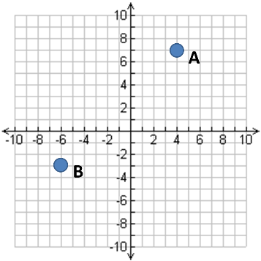  A: (4,7)  B: (-6,-3)
2. Midpoint of a Line | Method 1: add the x coordinates and divide by 2, add the y coordinates and divide by 2  Method 2: Sketch the line and find the values half way between the two x and two y values. | Find the midpoint between (2,1) and (6,9)  $\frac{2+6}{2}=4$ and $\frac{1+9}{2}=5$  So, the midpoint is (4,5)
3. Linear Graph | Straight line graph.  The general equation of a linear graph is  $$y=mx+c$$  where $m$ is the gradient and $c$ is the y-intercept.  The equation of a linear graph can contain an x-term, a y-term and a number. | Example:  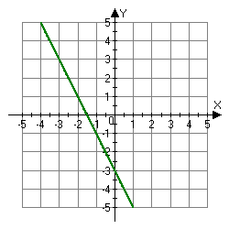  Other examples:  $x=y$  $y=4$  $x=-2$  $y=2x-7$  $y+x=10$  $2y-4x=12$
4. Plotting Linear Graphs | Method 1: Table of Values  Construct a table of values to calculate coordinates.  Method 2: Gradient-Intercept Method (use when the equation is in the form $y=mx+c$)  1. Plots the y-intercept  2. Using the gradient, plot a second point.  3. Draw a line through the two points plotted.  Method 3: Cover-Up Method (use when the equation is in the form $ax+by=c$)  1. Cover the $x$ term and solve the resulting equation. Plot this on the $x-axis.$  2. Cover the $y$ term and solve the resulting equation. Plot this on the $y-axis.$  3. Draw a line through the two points plotted. | 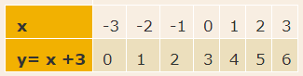  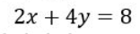
5. Gradient | The gradient of a line is how steep it is.  Gradient =  $$\frac{Change in y}{Change in x}=\frac{Rise}{Run}$$  The gradient can be positive (sloping upwards) or negative (sloping downwards) | 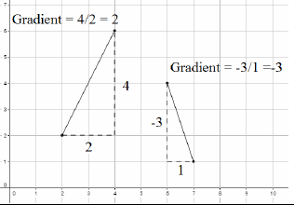
6. Finding the Equation of a Line given a point and a gradient | Substitute in the gradient (m) and point (x,y) in to the equation $y=mx+c$ and solve for c. | Find the equation of the line with gradient 4 passing through (2,7).  $$y=mx+c$$  $$7=4×2+c$$  $$c=-1$$  $$y=4x-1$$
7. Finding the Equation of a Line given two points | Use the two points to calculate the gradient. Then repeat the method above using the gradient and either of the points. | Find the equation of the line passing through (6,11) and (2,3)  $$m=\frac{11-3}{6-2}=2$$  $$y=mx+c$$  $$11=2×6+c$$  $$c=-1$$  $$y=2x-1$$
8. Parallel Lines | If two lines are parallel, they will have the same gradient. The value of m will be the same for both lines. | Are the lines $y=3x-1$ and $2y-6x+10=0$ parallel?  Answer:  Rearrange the second equation in to the form $y=mx+c$  $$2y-6x+10=0→y=3x-5$$  Since the two gradients are equal (3), the lines are parallel.

Knowledge Organiser

