Topic/Skill | Definition/Tips | Example  Topic: Sequences
1. Linear Sequence | A number pattern with a common difference. | 2, 5, 8, 11… is a linear sequence
2. Term | Each value in a sequence is called a term. | In the sequence 2, 5, 8, 11…, 8 is the third term of the sequence.
3. Term-to-term rule | A rule which allows you to find the next term in a sequence if you know the previous term. | First term is 2. Term-to-term rule is ‘add 3’  Sequence is: 2, 5, 8, 11…
4. nth term | A rule which allows you to calculate the term that is in the nth position of the sequence.  Also known as the ‘position-to-term’ rule.  n refers to the position of a term in a sequence. | nth term is $3n-1$  The 100th term is $3×100-1=299$
5. Finding the nth term of a linear sequence | 1. Find the difference.  2. Multiply that by $n.$  3. Substitute $n=1$ to find out what number you need to add or subtract to get the first number in the sequence. | Find the nth term of: 3, 7, 11, 15…  1. Difference is +4  2. Start with $4n$  3. $4×1=4$, so we need to subtract 1 to get 3.  nth term = $4n-1$
6. Fibonacci type sequences | A sequence where the next number is found by adding up the previous two terms | The Fibonacci sequence is:  $$1,1,2,3,5,8,13,21,34…$$  An example of a Fibonacci-type sequence is:  $$4, 7, 11, 18, 29…$$
7. Geometric Sequence | A sequence of numbers where each term is found by multiplying the previous one by a number called the common ratio, r. | An example of a geometric sequence is:  $$2, 10, 50, 250…$$  The common ratio is 5  Another example of a geometric sequence is:  $$81, -27, 9,-3, 1…$$  The common ratio is $-\frac{1}{3}$
11. Triangular numbers | The sequence which comes from a pattern of dots that form a triangle.  $$1, 3, 6, 10, 15, 21…$$ | 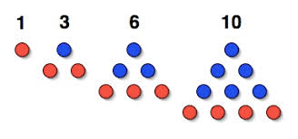

Topic/Skill | Definition/Tips | Example  Topic: Coordinates and Linear Graphs
1. Coordinates | Written in pairs. The first term is the x-coordinate (movement across). The second term is the y-coordinate (movement up or down) | 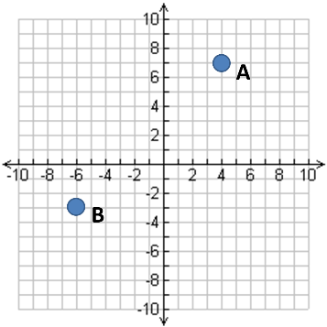  A: (4,7)  B: (-6,-3)
2. Midpoint of a Line | Method 1: add the x coordinates and divide by 2, add the y coordinates and divide by 2  Method 2: Sketch the line and find the values half way between the two x and two y values. | Find the midpoint between (2,1) and (6,9)  $\frac{2+6}{2}=4$ and $\frac{1+9}{2}=5$  So, the midpoint is (4,5)
3. Linear Graph | Straight line graph.  The general equation of a linear graph is  $$y=mx+c$$  where $m$ is the gradient and $c$ is the y-intercept.  The equation of a linear graph can contain an x-term, a y-term and a number. | Example:  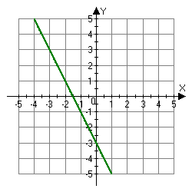  Other examples:  $x=y$  $y=4$  $x=-2$  $y=2x-7$  $y+x=10$  $2y-4x=12$
4. Plotting Linear Graphs | Method 1: Table of Values  Construct a table of values to calculate coordinates.  Method 2: Gradient-Intercept Method (use when the equation is in the form $y=mx+c$)  1. Plots the y-intercept  2. Using the gradient, plot a second point.  3. Draw a line through the two points plotted.  Method 3: Cover-Up Method (use when the equation is in the form $ax+by=c$)  1. Cover the $x$ term and solve the resulting equation. Plot this on the $x-axis.$  2. Cover the $y$ term and solve the resulting equation. Plot this on the $y-axis.$  3. Draw a line through the two points plotted. | 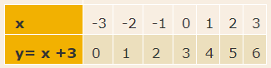  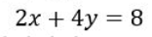

Knowledge Organiser

