Topic/Skill | Definition/Tips | Example  Topic: Perimeter and Area
1. Perimeter | The total distance around the outside of a shape.  Units include: $mm, cm, m$etc. | 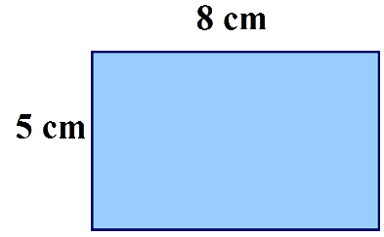  $P=8+5+8+5=26cm$
2. Area | The amount of space inside a shape.  Units include: $mm^{2}, cm^{2}, m^{2}$ | 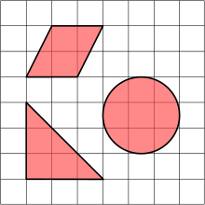
3. Area of a Rectangle | Length x Width | $A=36cm^{2}$
4. Area of a Parallelogram | Base x Perpendicular Height  Not the slant height. | $A=21cm^{2}$
5. Area of a Triangle | Base x Height ÷ 2 | 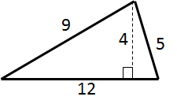$A=24cm^{2}$
6. Area of a Kite | Split in to two triangles and use the method above. | 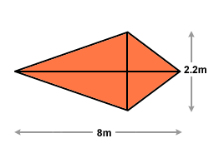 $A=8.8m^{2}$
7. Area of a Trapezium | $$\frac{(a+b)}{2}×h$$  “Half the sum of the parallel side, times the height between them. That is how you calculate the area of a trapezium” | 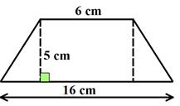 $A=55cm^{2}$
8. Compound Shape | A shape made up of a combination of other known shapes put together. | 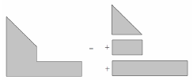

Topic/Skill | Definition/Tips | Example  Topic: Volume
1. Volume | Volume is a measure of the amount of space inside a solid shape.  Units: $mm^{3}, cm^{3},m^{3}$ etc.
2. Volume of a Cube/Cuboid | $$V=Length×Width×Height$$  $$V=L×W×H$$  You can also use the Volume of a Prism formula for a cube/cuboid.
3. Prism | A prism is a 3D shape whose cross section is the same throughout. | 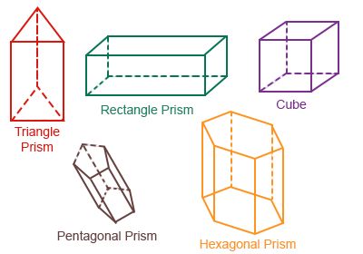
4. Cross Section | The cross section is the shape that continues all the way through the prism. | 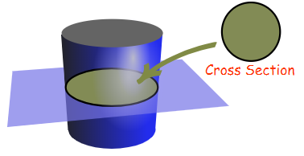
5. Volume of a Prism | $$V= Area of Cross Section×Length$$  $$V=A×L$$ | 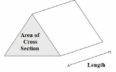
6. Volume of a Cylinder | $$V=πr^{2}h$$ | 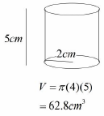
7. Volume of a Cone | $$V=\frac{1}{3}πr^{2}h$$ | 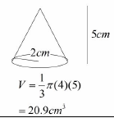
8. Volume of a Pyramid | $$Volume= \frac{1}{3}Bh$$  where B = area of the base | 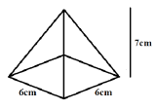  $$V=\frac{1}{3}×6×6×7=84{cm}^{3}$$
9. Volume of a Sphere | $$V=\frac{4}{3}πr^{3}$$  Look out for hemispheres – just halve the volume of a sphere. | Find the volume of a sphere with diameter 10cm.  $$V=\frac{4}{3}π{(5)}^{3}=\frac{500π}{3}{cm}^{3}$$
10. Frustums | A frustum is a solid (usually a cone or pyramid) with the top removed.  Find the volume of the whole shape, then take away the volume of the small cone/pyramid removed at the top. | 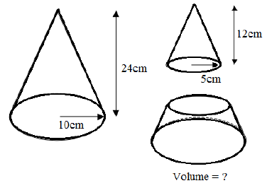  Topic: Geometry and Measures (H)  $$V=\frac{1}{3}π{\left(10\right)}^{2}\left(24\right)-\frac{1}{3}π{\left(5\right)}^{2}\left(12\right)=700π{cm}^{3}$$

Knowledge Organiser

