Topic/Skill | Definition/Tips | Example  Topic: Perimeter and Area
1. Perimeter | The total distance around the outside of a shape.  Units include: $mm, cm, m$etc. | 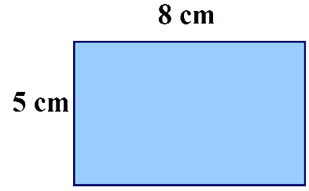  $P=8+5+8+5=26cm$
2. Area | The amount of space inside a shape.  Units include: $mm^{2}, cm^{2}, m^{2}$ | 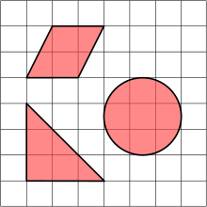
3. Area of a Rectangle | Length x Width | $A=36cm^{2}$
4. Area of a Parallelogram | Base x Perpendicular Height  Not the slant height. | $A=21cm^{2}$
5. Area of a Triangle | Base x Height ÷ 2 | 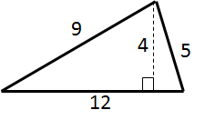$A=24cm^{2}$
6. Area of a Kite | Split in to two triangles and use the method above. | 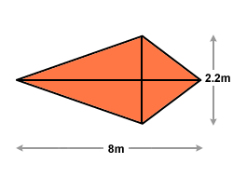 $A=8.8m^{2}$
7. Area of a Trapezium | $$\frac{(a+b)}{2}×h$$  “Half the sum of the parallel side, times the height between them. That is how you calculate the area of a trapezium” | 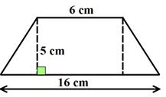 $A=55cm^{2}$
8. Compound Shape | A shape made up of a combination of other known shapes put together. | 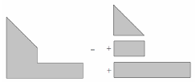

Topic/Skill | Definition/Tips | Example  Topic: Volume
1. Volume | Volume is a measure of the amount of space inside a solid shape.  Units: $mm^{3}, cm^{3},m^{3}$ etc.
2. Volume of a Cube/Cuboid | $$V=Length×Width×Height$$  $$V=L×W×H$$  You can also use the Volume of a Prism formula for a cube/cuboid.
3. Prism | A prism is a 3D shape whose cross section is the same throughout. | 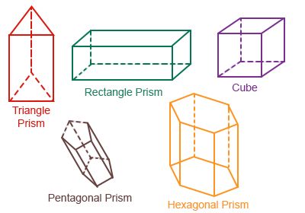
4. Cross Section | The cross section is the shape that continues all the way through the prism. | 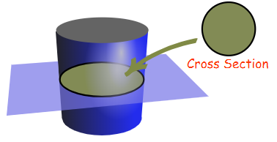
5. Volume of a Prism | $$V= Area of Cross Section×Length$$  $$V=A×L$$ | 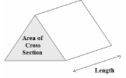
6. Volume of a Cylinder | $$V=πr^{2}h$$ | 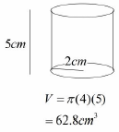
7. Volume of a Cone | $$V=\frac{1}{3}πr^{2}h$$ | 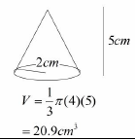
8. Volume of a Pyramid | $$Volume= \frac{1}{3}Bh$$  where B = area of the base | 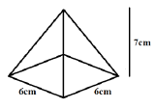  $$V=\frac{1}{3}×6×6×7=84{cm}^{3}$$
9. Volume of a Sphere | $$V=\frac{4}{3}πr^{3}$$  Look out for hemispheres – just halve the volume of a sphere. | Find the volume of a sphere with diameter 10cm.  $$V=\frac{4}{3}π{(5)}^{3}=\frac{500π}{3}{cm}^{3}$$
10. Frustums | A frustum is a solid (usually a cone or pyramid) with the top removed.  Find the volume of the whole shape, then take away the volume of the small cone/pyramid removed at the top. | 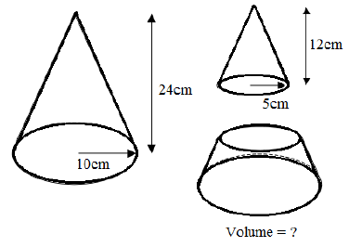  Topic: Geometry and Measures (H)  $$V=\frac{1}{3}π{\left(10\right)}^{2}\left(24\right)-\frac{1}{3}π{\left(5\right)}^{2}\left(12\right)=700π{cm}^{3}$$

Topic/Skill | Definition/Tips | Example  Topic: Circumference and Area
1. Circle | A circle is the locus of all points equidistant from a central point.
2. Parts of a Circle | Radius – the distance from the centre of a circle to the edge  Diameter – the total distance across the width of a circle through the centre.  Circumference – the total distance around the outside of a circle  Chord – a straight line whose end points lie on a circle  Tangent – a straight line which touches a circle at exactly one point  Arc – a part of the circumference of a circle  Sector – the region of a circle enclosed by two radii and their intercepted arc  Segment – the region bounded by a chord and the arc created by the chord | 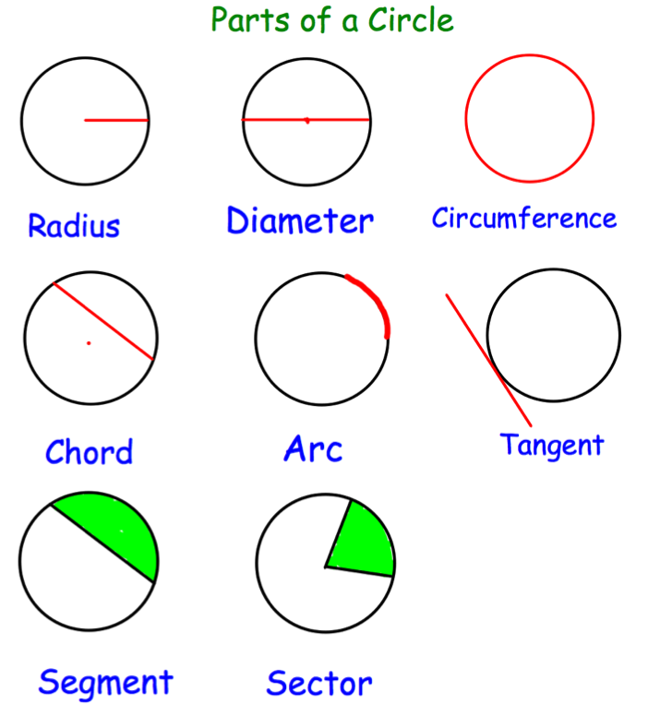
3. Area of a Circle | $A=πr^{2}$ which means ‘pi x radius squared’. | If the radius was 5cm, then:  $$A=π×5^{2}=78.5{cm}^{2}$$
4. Circumference of a Circle | $C=πd$ which means ‘pi x diameter’ | If the radius was 5cm, then:  $$C=π×10=31.4cm$$
5. $π$ (‘pi’) | Pi is the circumference of a circle divided by the diameter.  $$π≈3.14$$ | 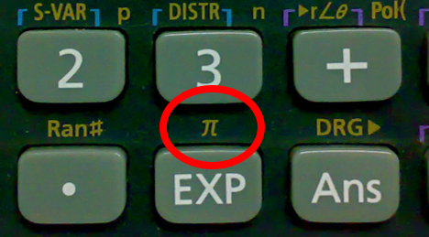
6. Arc Length of a Sector | The arc length is part of the circumference.  Take the angle given as a fraction over 360° and multiply by the circumference. | Arc Length = $\frac{115}{360}×π×8=8.03cm$  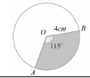
7. Area of a Sector | The area of a sector is part of the total area.  Take the angle given as a fraction over 360° and multiply by the area. | Area = $\frac{115}{360}×π×4^{2}=16.1{cm}^{2}$
8. Surface Area of a Cylinder | Curved Surface Area = $πdh$ or $2πrh$  Total SA = $2πr^{2}+πdh$ or $2πr^{2}+2πrh$ | 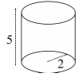  $$Total SA=2π{(2)}^{2}+π\left(4\right)\left(5\right)=28π$$
9. Surface Area of a Cone | Curved Surface Area = $πrl$  where $l=slant height$  Total SA = $πrl+ πr^{2}$  You may need to use Pythagoras’ Theorem to find the slant height | 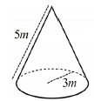  $$Total SA= π\left(3\right)\left(5\right)+π{(3)}^{2}=24π$$
10. Surface Area of a Sphere | $$SA=4πr^{2}$$  Look out for hemispheres – halve the SA of a sphere and add on a circle $(πr^{2})$ | Find the surface area of a sphere with radius 3cm.  $$SA=4π{(3)}^{2}=36π{cm}^{2}$$

Topic/Skill | Definition/Tips | Example  Topic: Accuracy
1. Place Value | The value of where a digit is within a number. | In 726, the value of the 2 is 20, as it is in the ‘tens’ column.
2. Place Value Columns | The names of the columns that determine the value of each digit.  The ‘ones’ column is also known as the ‘units’ column. | 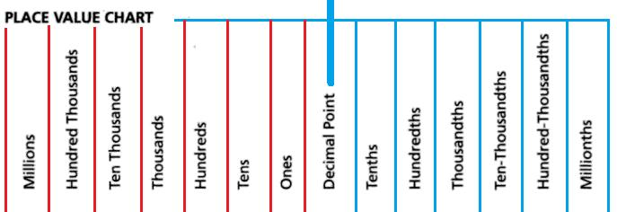
3. Rounding | To make a number simpler but keep its value close to what it was.  If the digit to the right of the rounding digit is less than 5, round down.  If the digit to the right of the rounding digit is 5 or more, round up. | 74 rounded to the nearest ten is 70, because 74 is closer to 70 than 80.  152,879 rounded to the nearest thousand is 153,000.
4. Decimal Place | The position of a digit to the right of a decimal point. | In the number 0.372, the 7 is in the second decimal place.  0.372 rounded to two decimal places is 0.37, because the 2 tells us to round down.  Careful with money - don’t write £27.4, instead write £27.40
5. Significant Figure | The significant figures of a number are the digits which carry meaning (ie. are significant) to the size of the number.  The first significant figure of a number cannot be zero.  In a number with a decimal, trailing zeros are not significant. | In the number 0.00821, the first significant figure is the 8.  In the number 2.740, the 0 is not a significant figure.  0.00821 rounded to 2 significant figures is 0.0082.  19357 rounded to 3 significant figures is 19400. We need to include the two zeros at the end to keep the digits in the same place value columns.
6. Truncation | A method of approximating a decimal number by dropping all decimal places past a certain point without rounding. | 3.14159265… can be truncated to 3.1415 (note that if it had been rounded, it would become 3.1416)
7. Error Interval | A range of values that a number could have taken before being rounded or truncated.  An error interval is written using inequalities, with a lower bound and an upper bound.  Note that the lower bound inequality can be ‘equal to’, but the upper bound cannot be ‘equal to’. | 0.6 has been rounded to 1 decimal place.  The error interval is:  $$0.55≤x<0.65$$  The lower bound is 0.55  The upper bound is 0.65
8. Estimate | To find something close to the correct answer. | An estimate for the height of a man is 1.8 metres.
9. Approximation | When using approximations to estimate the solution to a calculation, round each number in the calculation to 1 significant figure.  $≈$means ‘approximately equal to’ | $$\frac{348+692}{0.526}≈\frac{300+700}{0.5}=2000$$  ‘Note that dividing by 0.5 is the same as multiplying by 2’
10. Rational Number | A number of the form $\frac{p}{q}$, where $p$ and $q$ are integers and $q≠0.$  A number that cannot be written in this form is called an ‘irrational’ number | $\frac{4}{9}, 6, -\frac{1}{3}, \sqrt{25}$ are examples of rational numbers.  $π, \sqrt{2}$ are examples of an irrational numbers.
11. Surd | The irrational number that is a root of a positive integer, whose value cannot be determined exactly.  Surds have infinite non-recurring decimals. | $\sqrt{2}$ is a surd because it is a root which cannot be determined exactly.  $\sqrt{2}=1.41421356…$ which never repeats.
12. Rules of Surds | $$\sqrt{ab}=\sqrt{a}×\sqrt{b}$$  $$\sqrt{\frac{a}{b}}=\frac{\sqrt{a}}{\sqrt{b}}$$  $$a\sqrt{c}±b\sqrt{c}=\left(a±b\right)\sqrt{c}$$  $$\sqrt{a}×\sqrt{a}=a$$ | $$\sqrt{48}=\sqrt{16}×\sqrt{3}=4\sqrt{3}$$  $$\sqrt{\frac{25}{36}}=\frac{\sqrt{25}}{\sqrt{36}}=\frac{5}{6}$$  $$2\sqrt{5}+7\sqrt{5}=9\sqrt{5}$$  $$\sqrt{7}×\sqrt{7}=7$$
13. Rationalise a Denominator | The process of rewriting a fraction so that the denominator contains only rational numbers. | $$\frac{\sqrt{3}}{\sqrt{2}}=\frac{\sqrt{3}×\sqrt{2}}{\sqrt{2}×\sqrt{2}}=\frac{\sqrt{6}}{2}$$  $$\frac{6}{3+\sqrt{7}}=\frac{6\left(3-\sqrt{7}\right)}{\left(3+\sqrt{7}\right)\left(3-\sqrt{7}\right)}=\frac{18-6\sqrt{7}}{9-7}=\frac{18-6\sqrt{7}}{2}=9-3\sqrt{7}$$

Knowledge Organiser

