Topic/Skill | Definition/Tips | Example  Topic: Basic Probability
1. Probability | The likelihood/chance of something happening.  Is expressed as a number between 0 (impossible) and 1 (certain).  Can be expressed as a fraction, decimal, percentage or in words (likely, unlikely, even chance etc.) | 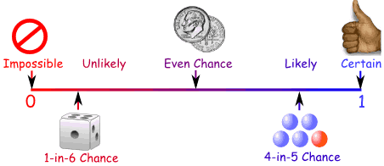
2. Probability Notation | P(A) refers to the probability that event A will occur. | P(Red Queen) refers to the probability of picking a Red Queen from a pack of cards.
3. Theoretical Probability | $$\frac{Number of Favourable Outcomes}{Total Number of Possible Outcomes}$$ | Probability of rolling a 4 on a fair 6-sided die = $\frac{1}{6}$.
4. Relative Frequency | $$\frac{Number of Successful Trials}{Total Number of Trials}$$ | A coin is flipped 50 times and lands on Tails 29 times.  The relative frequency of getting Tails = $\frac{29}{50}$.
5. Expected Outcomes | To find the number of expected outcomes, multiply the probability by the number of trials. | The probability that a football team wins is 0.2 How many games would you expect them to win out of 40?  $$0.2 × 40 = 8 games$$
6. Exhaustive | Outcomes are exhaustive if they cover the entire range of possible outcomes.  The probabilities of an exhaustive set of outcomes adds up to 1. | When rolling a six-sided die, the outcomes 1, 2, 3, 4, 5 and 6 are exhaustive, because they cover all the possible outcomes.
7. Mutually Exclusive | Events are mutually exclusive if they cannot happen at the same time.  The probabilities of an exhaustive set of mutually exclusive events adds up to 1. | Examples of mutually exclusive events:  - Turning left and right  - Heads and Tails on a coin  Examples of non mutually exclusive events:  - King and Hearts from a deck of cards, because you can pick the King of Hearts
8. Frequency Tree | A diagram showing how information is categorised into various categories.  The numbers at the ends of branches tells us how often something happened (frequency).  The lines connected the numbers are called branches. | 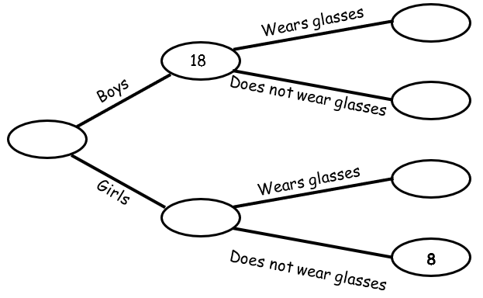
9. Sample Space | The set of all possible outcomes of an experiment.
10. Sample | A sample is a small selection of items from a population.  A sample is biased if individuals or groups from the population are not represented in the sample. | A sample could be selecting 10 students from a year group at school.
11. Sample Size | The larger a sample size, the closer those probabilities will be to the true probability. | A sample size of 100 gives a more reliable result than a sample size of 10.

Knowledge Organiser

