Topic/Skill | Definition/Tips | Example  Topic: Coordinates and Linear Graphs
1. Coordinates | Written in pairs. The first term is the x-coordinate (movement across). The second term is the y-coordinate (movement up or down) | 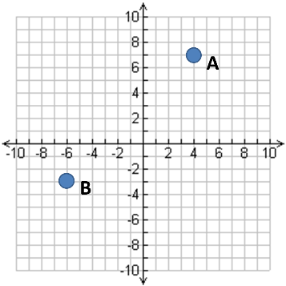  A: (4,7)  B: (-6,-3)
2. Midpoint of a Line | Method 1: add the x coordinates and divide by 2, add the y coordinates and divide by 2  Method 2: Sketch the line and find the values half way between the two x and two y values. | Find the midpoint between (2,1) and (6,9)  $\frac{2+6}{2}=4$ and $\frac{1+9}{2}=5$  So, the midpoint is (4,5)
3. Linear Graph | Straight line graph.  The general equation of a linear graph is  $$y=mx+c$$  where $m$ is the gradient and $c$ is the y-intercept.  The equation of a linear graph can contain an x-term, a y-term and a number. | Example:  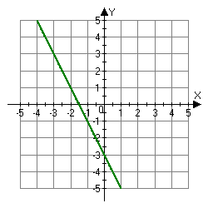  Other examples:  $x=y$  $y=4$  $x=-2$  $y=2x-7$  $y+x=10$  $2y-4x=12$
4. Plotting Linear Graphs | Method 1: Table of Values  Construct a table of values to calculate coordinates.  Method 2: Gradient-Intercept Method (use when the equation is in the form $y=mx+c$)  1. Plots the y-intercept  2. Using the gradient, plot a second point.  3. Draw a line through the two points plotted.  Method 3: Cover-Up Method (use when the equation is in the form $ax+by=c$)  1. Cover the $x$ term and solve the resulting equation. Plot this on the $x-axis.$  2. Cover the $y$ term and solve the resulting equation. Plot this on the $y-axis.$  3. Draw a line through the two points plotted. | 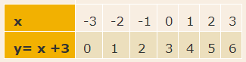  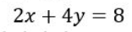
5. Gradient | The gradient of a line is how steep it is.  Gradient =  $$\frac{Change in y}{Change in x}=\frac{Rise}{Run}$$  The gradient can be positive (sloping upwards) or negative (sloping downwards) | 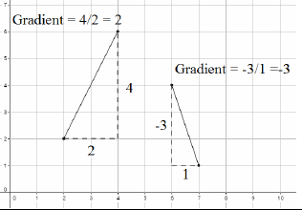
6. Finding the Equation of a Line given a point and a gradient | Substitute in the gradient (m) and point (x,y) in to the equation $y=mx+c$ and solve for c. | Find the equation of the line with gradient 4 passing through (2,7).  $$y=mx+c$$  $$7=4×2+c$$  $$c=-1$$  $$y=4x-1$$
7. Finding the Equation of a Line given two points | Use the two points to calculate the gradient. Then repeat the method above using the gradient and either of the points. | Find the equation of the line passing through (6,11) and (2,3)  $$m=\frac{11-3}{6-2}=2$$  $$y=mx+c$$  $$11=2×6+c$$  $$c=-1$$  $$y=2x-1$$
8. Parallel Lines | If two lines are parallel, they will have the same gradient. The value of m will be the same for both lines. | Are the lines $y=3x-1$ and $2y-6x+10=0$ parallel?  Answer:  Rearrange the second equation in to the form $y=mx+c$  $$2y-6x+10=0→y=3x-5$$  Since the two gradients are equal (3), the lines are parallel.
9. Perpendicular Lines | If two lines are perpendicular, the product of their gradients will always equal -1.  The gradient of one line will be the negative reciprocal of the gradient of the other line.  You may need to rearrange equations of lines to compare gradients (they need to be in the form $y=mx+c)$ | Find the equation of the line perpendicular to $y=3x+2$ which passes through (6,5)  Answer:  As they are perpendicular, the gradient of the new line will be $-\frac{1}{3}$ as this is the negative reciprocal of 3.  $$y=mx+c$$  $$5=-\frac{1}{3}×6+c$$  $$c=7$$  $$y=-\frac{1}{3}x+7$$  Or  $$3x+x-7=0$$

Topic/Skill | Definition/Tips  Topic: Non-linear Graphs | Example
1. Coordinates | Written in pairs. The first term is the x-coordinate (movement across). The second term is the y-coordinate (movement up or down) | A: (4,7)  B: (-6,-3)
2. Linear Graph | Straight line graph.  The equation of a linear graph can contain an x-term, a y-term and a number. | Example:  Other examples:  $x=y$  $y=4$  $x=-2$  $y=2x-7$  $y+x=10$  $2y-4x=12$
3. Quadratic Graph | A ‘U-shaped’ curve called a parabola.  The equation is of the form  $y=ax^{2}+bx+c$, where $a$, $b$ and $c$ are numbers, $a≠0$.  If $a<0$, the parabola is upside down. | 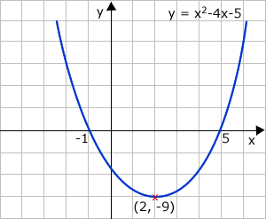
4. Cubic Graph | The equation is of the form $y={ax}^{3}+k$, where $k$ is an number.  If $a>0$, the curve is increasing.  If $a<0$, the curve is decreasing.
5. Reciprocal Graph | The equation is of the form $y=\frac{A}{x}$, where $A$ is a number and $x≠0$.  The graph has asymptotes on the x-axis and y-axis. | 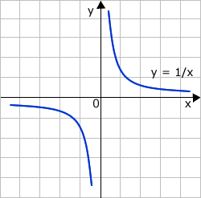
6. Asymptote | A straight line that a graph approaches but never touches.  Subject: Maths | 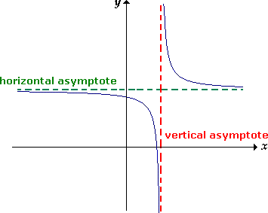
7. Exponential Graph | The equation is of the form $y=a^{x}$, where $a$is a number called the base.  If $a>1$ the graph increases.  If $0<a<1$, the graph decreases.  The graph has an asymptote which is the x-axis.

Topic/Skill | Definition/Tips  Topic: Equation of a Circle and Tangent | Example
1. Equation of a Circle | The equation of a circle, centre (0,0), radius r, is:  $$x^{2}+y^{2}=r^{2}$$ | 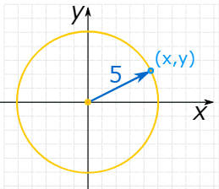  $$x^{2}+y^{2}=25$$
2. Tangent | A straight line that touches a circle at exactly one point, never entering the circle’s interior.  A radius is perpendicular to a tangent at the point of contact. | 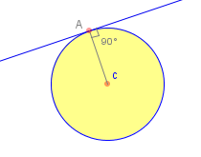
3. Gradient | Gradient is another word for slope.  $$G= \frac{Rise}{Run}= \frac{Change in y}{Change in x}= \frac{y_{2}-y_{1}}{x_{2}-x_{1}}$$ | 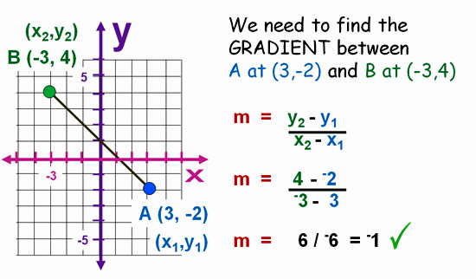
4. Circle Theorem 5 | A tangent is perpendicular to the radius at the point of contact.  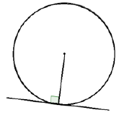 | 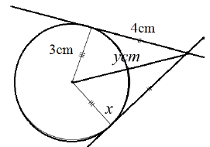  $y=5cm$(Pythagoras’ Theorem)

Knowledge Organiser

