Topic/Skill | Definition/Tips | Example  Topic: Angles
1. Types of Angles | Acute angles are less than 90°.  Right angles are exactly 90°.  Obtuse angles are greater than 90° but less than 180°.  Reflex angles are greater than 180° but less than 360°. | 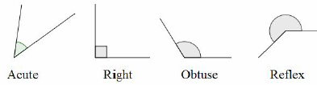
2. Angle Notation | Can use one lower-case letters, eg. $θ$ or $x$  Can use three upper-case letters, eg. $BAC$ | 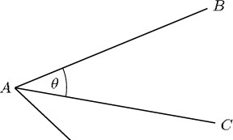
3. Angles at a Point | Angles around a point add up to 360°. | 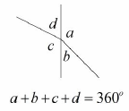
4. Angles on a Straight Line | Angles around a point on a straight line add up to 180°. | 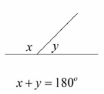
5. Opposite Angles | Vertically opposite angles are equal. | 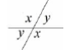
6. Alternate Angles | Alternate angles are equal.  They look like Z angles, but never say this in the exam. | 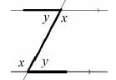
7. Corresponding Angles | Corresponding angles are equal.  They look like F angles, but never say this in the exam. | 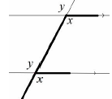
8. Co-Interior Angles | Co-Interior angles add up to 180°.  They look like C angles, but never say this in the exam. | 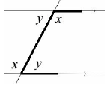
9. Angles in a Triangle | Angles in a triangle add up to 180°. | 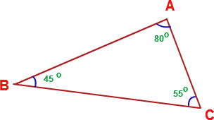
10. Types of Triangles | Right Angle Triangles have a 90° angle in.  Isosceles Triangles have 2 equal sides and 2 equal base angles.  Equilateral Triangles have 3 equal sides and 3 equal angles (60°).  Scalene Triangles have different sides and different angles.  Base angles in an isosceles triangle are equal. | 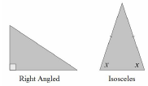  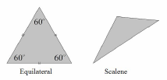
11. Angles in a Quadrilateral | Angles in a quadrilateral add up to 360°.
12. Polygon | A 2D shape with only straight edges. | Rectangle, Hexagon, Decagon, Kite etc.
13. Regular | A shape is regular if all the sides and all the angles are equal.
14. Names of Polygons | 3-sided = Triangle  4-sided = Quadrilateral  5-sided = Pentagon  6-sided = Hexagon  7-sided = Heptagon/Septagon  8-sided = Octagon  9-sided = Nonagon  10-sided = Decagon | 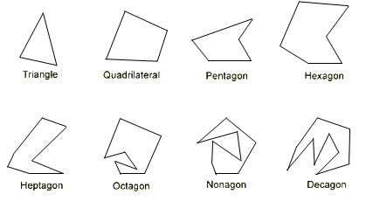
15. Sum of Interior Angles | $$(n-2)×180$$  where n is the number of sides. | Sum of Interior Angles in a Decagon = $\left(10-2\right)×180=1440°$
16. Size of Interior Angle in a Regular Polygon | $$\frac{(n-2)×180}{n}$$  You can also use the formula:  $$180-Size of Exterior Angle$$ | Size of Interior Angle in a Regular Pentagon =  $$\frac{(5-2)×180}{5}=108°$$
17. Size of Exterior Angle in a Regular Polygon | $$\frac{360}{n}$$  You can also use the formula:  $$180-Size of Interior Angle$$ | Size of Exterior Angle in a Regular Octagon =  $$\frac{360}{8}=45°$$

Topic/Skill | Definition/Tips | Example  Topic: Pythagoras’ Theorem
1. Pythagoras’ Theorem | For any right angled triangle:  $$a^{2}+b^{2}=c^{2}$$  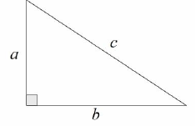  Used to find missing lengths.  a and b are the shorter sides, c is the hypotenuse (longest side). | 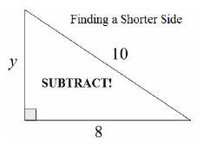  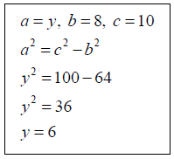
2. 3D Pythagoras’ Theorem | Find missing lengths by identifying right angled triangles.  You will often have to find a missing length you are not asked for before finding the missing length you are asked for. | Can a pencil that is 20cm long fit in a pencil tin with dimensions 12cm, 13cm and 9cm? The pencil tin is in the shape of a cuboid.  Hypotenuse of the base = $\sqrt{{12}^{2}+{13}^{2}}=17.7$  Diagonal of cuboid = $\sqrt{{17.7}^{2}+9^{2}}=19.8cm$  No, the pencil cannot fit.

Topic/Skill | Definition/Tips | Example  Topic: Right Angled Trigonometry
1. Trigonometry | The study of triangles.
2. Hypotenuse | The longest side of a right-angled triangle.  Is always opposite the right angle. | 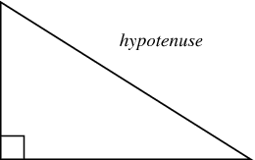
3. Adjacent | Next to | 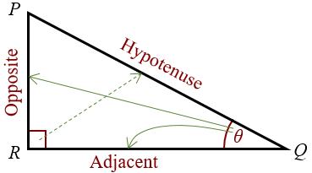
4. Trigonometric Formulae | Use SOHCAHTOA.  $$\sin{θ}=\frac{O}{H}$$  $$\cos{θ}=\frac{A}{H}$$  $$\tan{θ}=\frac{O}{A}$$  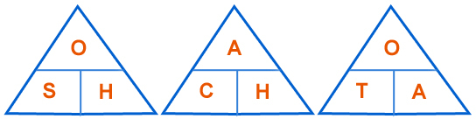  When finding a missing angle, use the ‘inverse’ trigonometric function by pressing the ‘shift’ button on the calculator. | 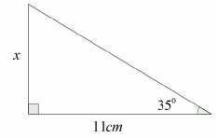  Use ‘Opposite’ and ‘Adjacent’, so use ‘tan’  $$\tan{35=}\frac{x}{11}$$  $$x=11\tan{35}=7.70cm$$  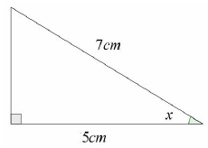  Use ‘Adjacent’ and ‘Hypotenuse’, so use ‘cos’  $$\cos{x}=\frac{5}{7}$$  $$x=\cos^{-1}\left(\frac{5}{7}\right)=44.4°$$
5. 3D Trigonometry | Find missing lengths by identifying right angled triangles.  You will often have to find a missing length you are not asked for before finding the missing length you are asked for. | 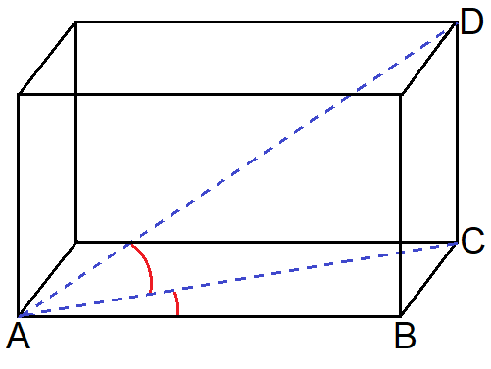

Knowledge Organiser

