Topic/Skill | Definition/Tips | Example  Topic: Compound Measures
1. Metric System | A system of measures based on:  - the metre for length  - the kilogram for mass  - the second for time  Length: mm, cm, m, km  Mass: mg, g, kg  Volume: ml, cl, l | $$1kilometres=1000 metres$$  $$1 metre=100 centimetres$$  $$1 centimetre=10 millimetres$$  $$1 kilogram=1000 grams$$
2. Imperial System | A system of weights and measures originally developed in England, usually based on human quantities  Length: inch, foot, yard, miles  Mass: lb, ounce, stone  Volume: pint, gallon | $$1lb=16 ounces$$  $$1 foot=12 inches$$  $$1 gallon=8 pints$$
3. Metric and Imperial Units | Use the unitary method to convert between metric and imperial units. | $$5 miles≈8 kilometres$$  $$1 gallon≈4.5 litres$$  $$2.2 pounds≈1 kilogram$$  $$1 inch=2.5 centimetres$$
4. Speed, Distance, Time | Speed = Distance ÷ Time  Distance = Speed x Time  Time = Distance ÷ Speed  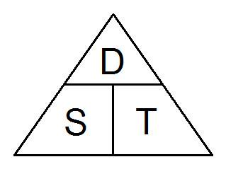  Remember the correct units. | Speed = 4mph  Time = 2 hours  Find the Distance.  $$D = S × T = 4 × 2 = 8 miles$$
5. Density, Mass, Volume | Density = Mass ÷ Volume  Mass = Density x Volume  Volume = Mass ÷ Density  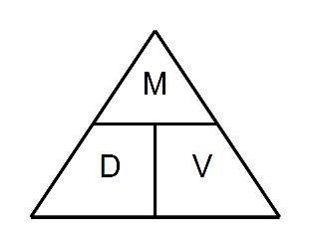  Remember the correct units. | Density = 8kg/m³  Mass = 2000g  Find the Volume.  $$V = M ÷ D = 2 ÷ 8 = 0.25m³$$
6. Pressure, Force, Area | Pressure = Force ÷ Area  Force = Pressure x Area  Area = Force ÷ Pressure  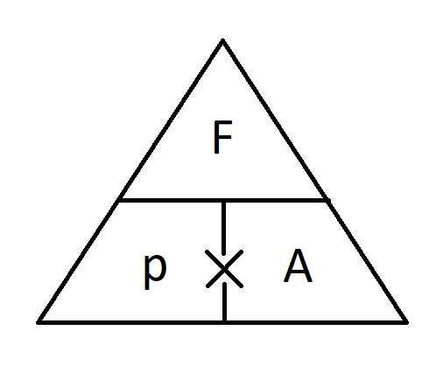  Remember the correct units. | Pressure = 10 Pascals  Area = 6cm²  Find the Force  $$F=P×A=10×6=60 N$$
7. Enlargement | The shape will get bigger or smaller. Multiply each side by the scale factor. | Scale Factor = 3 means ‘3 times larger = multiply by 3’  Scale Factor = ½ means ‘half the size = divide by 2’

Topic/Skill | Definition/Tips | Example  Topic: Calculating with Percentages
1. Increase or Decrease by a Percentage | Non-calculator: Find the percentage and add or subtract it from the original amount.  Calculator: Find the percentage multiplier and multiply. | Increase 500 by 20% (Non Calc):  10% of 500 = 50  so 20% of 500 = 100  500 + 100 = 600  Decrease 800 by 17% (Calc):  100%-17%=83%  83% ÷ 100 = 0.83  0.83 x 800 = 664
2. Percentage Multiplier | The number you multiply a quantity by to increase or decrease it by a percentage. | The multiplier for increasing by 12% is 1.12  The multiplier for decreasing by 12% is 0.88  The multiplier for increasing by 100% is 2.
3. Reverse Percentage | Find the correct percentage given in the question, then work backwards to find 100%  Look out for words like ‘before’ or ‘original’ | A jumper was priced at £48.60 after a 10% reduction. Find its original price.  100% - 10% = 90%  90% = £48.60  1% = £0.54  100% = £54
4. Simple Interest | Interest calculated as a percentage of the original amount. | £1000 invested for 3 years at 10% simple interest.  10% of £1000 = £100  Interest = $3×£100=£300$

Knowledge Organiser

