Topic/Skill | Definition/Tips | Example  Topic: Summarising Data
1. Types of Data | Qualitative Data – non-numerical data  Quantitative Data – numerical data  Continuous Data – data that can take any numerical value within a given range.  Discrete Data – data that can take only specific values within a given range. | Qualitative Data – eye colour, gender etc.  Continuous Data – weight, voltage etc.  Discrete Data – number of children, shoe size etc.
2. Grouped Data | Data that has been bundled in to categories.  Seen in grouped frequency tables, histograms, cumulative frequency etc. | 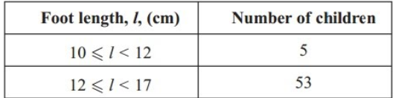
3. Primary /Secondary Data | Primary Data – collected yourself for a specific purpose.  Secondary Data – collected by someone else for another purpose. | Primary Data – data collected by a student for their own research project.  Secondary Data – Census data used to analyse link between education and earnings.
4. Mean | Add up the values and divide by how many values there are. | The mean of 3, 4, 7, 6, 0, 4, 6 is  $$\frac{3+4+7+6+0+4+6}{7}=5$$
5. Mean from a Table | 1. Find the midpoints (if necessary)  2. Multiply Frequency by values or midpoints  3. Add up these values  4. Divide this total by the Total Frequency  If grouped data is used, the answer will be an estimate. | 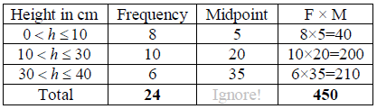  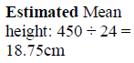
6. Median Value | The middle value.  Put the data in order and find the middle one.  If there are two middle values, find the number half way between them by adding them together and dividing by 2. | Find the median of: 4, 5, 2, 3, 6, 7, 6  Ordered: 2, 3, 4, 5, 6, 6, 7  Median = 5
7. Median from a Table | Use the formula $\frac{(n+1)}{2}$ to find the position of the median.  $n$ is the total frequency. | If the total frequency is 15, the median will be the $\left(\frac{15+1}{2}\right)=8th$position
8. Mode /Modal Value | Most frequent/common.  Can have more than one mode (called bi-modal or multi-modal) or no mode (if all values appear once) | Find the mode: 4, 5, 2, 3, 6, 4, 7, 8, 4  Mode = 4
9. Range | Highest value subtract the Smallest value  Range is a ‘measure of spread’. The smaller the range the more consistent the data. | Find the range: 3, 31, 26, 102, 37, 97.  Range = 102-3 = 99
10. Outlier | A value that ‘lies outside’ most of the other values in a set of data.  An outlier is much smaller or much larger than the other values in a set of data. | 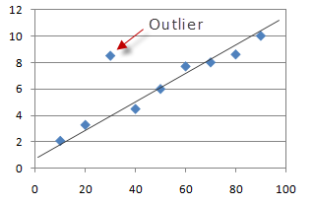
11. Lower Quartile | Divides the bottom half of the data into two halves.  LQ = $Q_{1}=\frac{(n+1)}{4}th$value | Find the lower quartile of: 2, 3, 4, 5, 6, 6, 7  $Q_{1}=\frac{(7+1)}{4}=2nd$value 3
12. Lower Quartile | Divides the top half of the data into two halves.  UQ = $Q_{3}=\frac{3(n+1)}{4}th$value | Find the upper quartile of: 2, 3, 4, 5, 6, 6, 7  $Q_{3}=\frac{3(7+1)}{4}=6th$value 6
13. Interquartile Range | The difference between the upper quartile and lower quartile.  $$IQR=Q_{3}-Q_{1}$$  The smaller the interquartile range, the more consistent the data. | Find the IQR of: 2, 3, 4, 5, 6, 6, 7  $$IQR=Q_{3}-Q_{1}=6-3=3$$

Topic/Skill | Definition/Tips | Example  Topic: Representing Data
1. Frequency Table | A record of how often each value in a set of data occurs. | 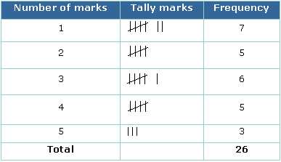
2. Bar Chart | Represents data as vertical blocks.  $x-axis$ shows the type of data  $y-axis$ shows the frequency for each type of data  Each bar should be the same width  There should be gaps between each bar  Remember to label each axis. | 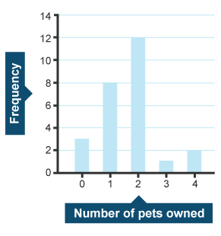
3. Types of Bar Chart | Compound/Composite Bar Charts show data stacked on top of each other.  Comparative/Dual Bar Charts show data side by side. | 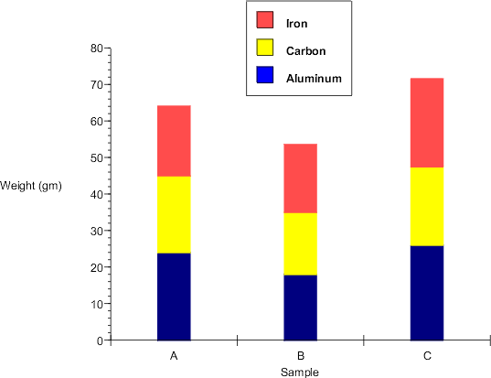  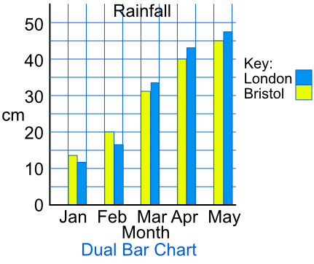
4. Pie Chart | Used for showing how data breaks down into its constituent parts.  When drawing a pie chart, divide 360° by the total frequency. This will tell you how many degrees to use for the frequency of each category.  Remember to label the category that each sector in the pie chart represents. | If there are 40 people in a survey, then each person will be worth 360÷40=9° of the pie chart.
5. Pictogram | Uses pictures or symbols to show the value of the data.  A pictogram must have a key. | 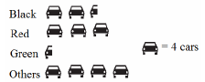
6. Line Graph | A graph that uses points connected by straight lines to show how data changes in values.  This can be used for time series data, which is a series of data points spaced over uniform time intervals in time order. | 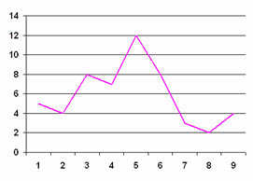
7. Two Way Tables | A table that organises data around two categories.  Fill out the information step by step using the information given.  Make sure all the totals add up for all columns and rows. | 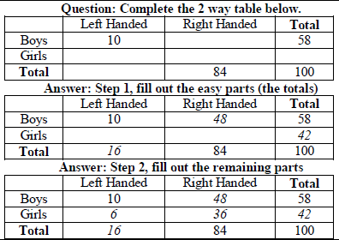
8. Box Plots | The minimum, lower quartile, median, upper quartile and maximum are shown on a box plot.  A box plot can be drawn independently or from a cumulative frequency diagram. | Students sit a maths test. The highest score is 19, the lowest score is 8, the median is 14, the lower quartile is 10 and the upper quartile is 17. Draw a box plot to represent this information.  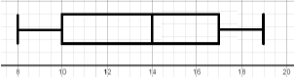
9. Comparing Box Plots | Write two sentences.  1. Compare the averages using the medians for two sets of data.  2. Compare the spread of the data using the range or IQR for two sets of data.  The smaller the range/IQR, the more consistent the data.  You must compare box plots in the context of the problem. | ‘On average, students in class A were more successful on the test than class B because their median score was higher.’  ‘Students in class B were more consistent than class A in their test scores as their IQR was smaller.’

Topic/Skill | Definition/Tips | Example  Topic: Systematic Listing
1. Combination | A collection of things, where the order does not matter. | How many combinations of two ingredients can you make with apple, banana and cherry?  Apple, Banana  Apple, Cherry  Banana, Cherry  3 combinations
2. Permutation | A collection of things, where the order does matter. | You want to visit the homes of three friends, Alex (A), Betty (B) and Chandra (C) but haven’t decided the order. What choices do you have?  ABC  ACB  BAC  BCA  CAB  CBA
3. Permutations with Repetition | When something has $n$ different types, there are $n$ choices each time.  Choosing $r$ of something that has $n$ different types, the permutations are:  $$n×n×…\left(r times\right)=n^{r}$$ | How many permutations are there for a three-number combination lock?  10 numbers to choose from $\{1, 2, ….10\}$ and we choose 3 of them  $10×10×10={10}^{3}=1000$ permutations.
4. Permutations without Repetition | We have to reduce the number of available choices each time.  One you have chosen something, you cannot choose it again. | How many ways can you order 4 numbered balls?  $$4×3×2×1=24$$
5. Factorial | The factorial symbol ‘!’ means to multiply a series of descending integers to 1.  Note: $0!=1$ | $$4!=4×3×2×1=24$$
6. Product Rule for Counting | If there are $x$ ways of doing something and $y$ ways of doing something else, then there are $xy$ ways of performing both. | To choose one of $\{A,B,C\}$ and one of $\{X,Y\}$ means to choose one of $\{AX, AY, BX, BY, CX, CY\}$  The rule says that there are $3×2=6$ choices.

Topic/Skill | Definition/Tips  Topic: Scatter Graphs | Example
1. Correlation | Correlation between two sets of data means they are connected in some way. | There is correlation between temperature and the number of ice creams sold.
2. Causality | When one variable influences another variable. | The more hours you work at a particular job (paid hourly), the higher your income from that job will be.
3. Positive Correlation | As one value increases the other value increases.
4. Negative Correlation | As one value increases the other value decreases.
5. No Correlation | There is no linear relationship between the two.
6. Strong Correlation | When two sets of data are closely linked.
7. Weak Correlation | When two sets of data have correlation, but are not closely linked.
8. Scatter Graph | A graph in which values of two variables are plotted along two axes to compare them and see if there is any connection between them. | 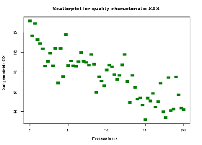
9. Line of Best Fit | A straight line that best represents the data on a scatter graph. | 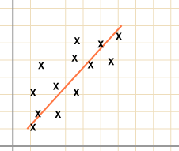
10. Outlier | A value that ‘lies outside’ most of the other values in a set of data.  An outlier is much smaller or much larger than the other values in a set of data.

Topic/Skill | Definition/Tips | Example  Topic: Real Life Graphs
1. Real Life Graphs | Graphs that are supposed to model some real-life situation.  The actual meaning of the values depends on the labels and units on each axis.  The gradient might have a contextual meaning.  The y-intercept might have a contextual meaning.  The area under the graph might have a contextual meaning. | A graph showing the cost of hiring a ladder for various numbers of days.  The gradient shows the cost per day. It costs £3/day to hire the ladder.  The y-intercept shows the additional cost/deposit/fixed charge (something not linked to how long the ladder is hired for). The additional cost is £7.
2. Conversion Graph | A line graph to convert one unit to another.  Can be used to convert units (eg. miles and kilometres) or currencies ($ and £)  Find the value you know on one axis, read up/across to the conversion line and read the equivalent value from the other axis. | 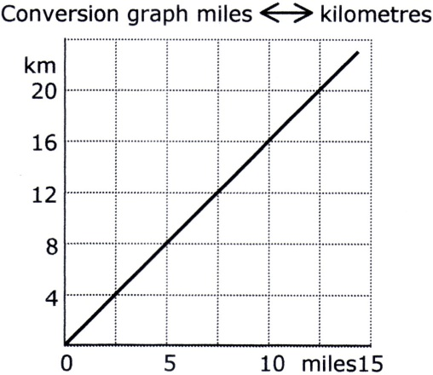  $$8 km=5 miles$$
3. Depth of Water in Containers | Graphs can be used to show how the depth of water changes as different shaped containers are filled with water at a constant rate. | 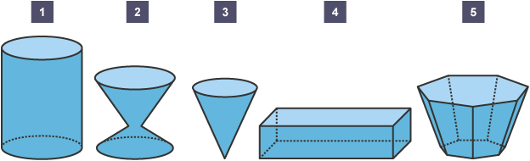  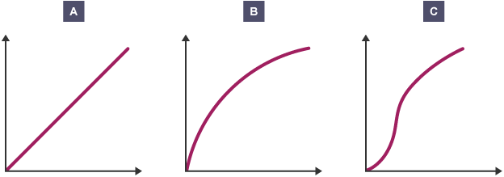

Knowledge Organiser

