Topic/Skill | Definition/Tips | Example  Topic: Representing Data
1. Frequency Table | A record of how often each value in a set of data occurs. | 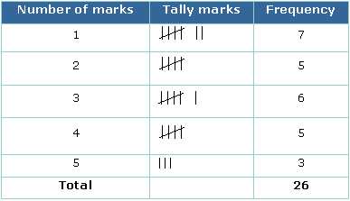
2. Bar Chart | Represents data as vertical blocks.  $x-axis$ shows the type of data  $y-axis$ shows the frequency for each type of data  Each bar should be the same width  There should be gaps between each bar  Remember to label each axis. | 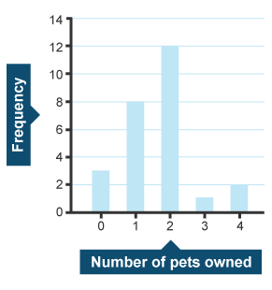
3. Types of Bar Chart | Compound/Composite Bar Charts show data stacked on top of each other.  Comparative/Dual Bar Charts show data side by side. | 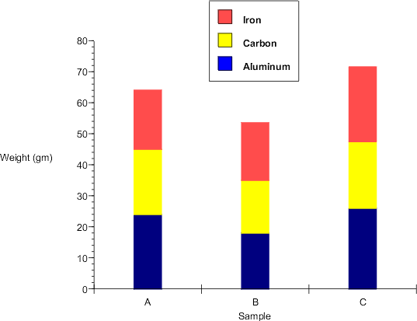  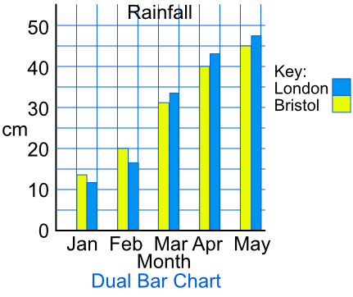
4. Pie Chart | Used for showing how data breaks down into its constituent parts.  When drawing a pie chart, divide 360° by the total frequency. This will tell you how many degrees to use for the frequency of each category.  Remember to label the category that each sector in the pie chart represents. | If there are 40 people in a survey, then each person will be worth 360÷40=9° of the pie chart.
5. Pictogram | Uses pictures or symbols to show the value of the data.  A pictogram must have a key. | 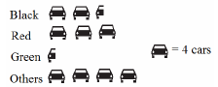
6. Line Graph | A graph that uses points connected by straight lines to show how data changes in values.  This can be used for time series data, which is a series of data points spaced over uniform time intervals in time order. | 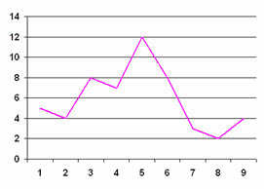
7. Two Way Tables | A table that organises data around two categories.  Fill out the information step by step using the information given.  Make sure all the totals add up for all columns and rows. | 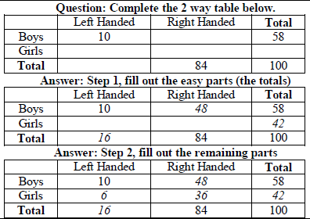

Topic/Skill | Definition/Tips  Topic: Scatter Graphs | Example
1. Correlation | Correlation between two sets of data means they are connected in some way. | There is correlation between temperature and the number of ice creams sold.
2. Causality | When one variable influences another variable. | The more hours you work at a particular job (paid hourly), the higher your income from that job will be.
3. Positive Correlation | As one value increases the other value increases.
4. Negative Correlation | As one value increases the other value decreases.
5. No Correlation | There is no linear relationship between the two.
6. Strong Correlation | When two sets of data are closely linked.
7. Weak Correlation | When two sets of data have correlation, but are not closely linked.
8. Scatter Graph | A graph in which values of two variables are plotted along two axes to compare them and see if there is any connection between them. | 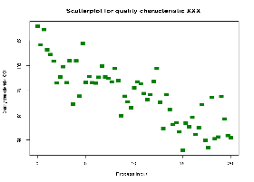
9. Line of Best Fit | A straight line that best represents the data on a scatter graph. | 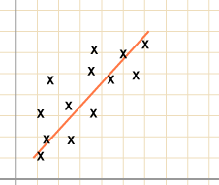
10. Outlier | A value that ‘lies outside’ most of the other values in a set of data.  An outlier is much smaller or much larger than the other values in a set of data. | 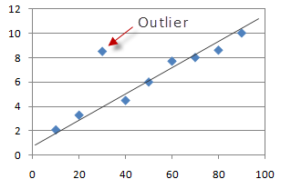

Topic/Skill | Definition/Tips | Example  Topic: Systematic Listing
1. Combination | A collection of things, where the order does not matter. | How many combinations of two ingredients can you make with apple, banana and cherry?  Apple, Banana  Apple, Cherry  Banana, Cherry  3 combinations
2. Permutation | A collection of things, where the order does matter. | You want to visit the homes of three friends, Alex (A), Betty (B) and Chandra (C) but haven’t decided the order. What choices do you have?  ABC  ACB  BAC  BCA  CAB  CBA
3. Permutations with Repetition | When something has $n$ different types, there are $n$ choices each time.  Choosing $r$ of something that has $n$ different types, the permutations are:  $$n×n×…\left(r times\right)=n^{r}$$ | How many permutations are there for a three-number combination lock?  10 numbers to choose from $\{1, 2, ….10\}$ and we choose 3 of them  $10×10×10={10}^{3}=1000$ permutations.
4. Permutations without Repetition | We have to reduce the number of available choices each time.  One you have chosen something, you cannot choose it again. | How many ways can you order 4 numbered balls?  $$4×3×2×1=24$$
5. Factorial | The factorial symbol ‘!’ means to multiply a series of descending integers to 1.  Note: $0!=1$ | $$4!=4×3×2×1=24$$

Knowledge Organiser

