Topic/Skill | Definition/Tips | Example  Topic: Factors and Multiples
1. Multiple | The result of multiplying a number by an integer.  The times tables of a number. | The first five multiples of 7 are:  $$7, 14, 21, 28, 35$$
2. Factor | A number that divides exactly into another number without a remainder.  It is useful to write factors in pairs | The factors of 18 are:  $$1, 2, 3, 6, 9, 18$$  The factor pairs of 18 are:  $$1, 18$$  $$2, 9$$  $$3, 6$$
3. Lowest Common Multiple (LCM) | The smallest number that is in the times tables of each of the numbers given. | The LCM of 3, 4 and 5 is 60 because it is the smallest number in the 3, 4 and 5 times tables.
4. Highest Common Factor (HCF) | The biggest number that divides exactly into two or more numbers. | The HCF of 6 and 9 is 3 because it is the biggest number that divides into 6 and 9 exactly.
5. Prime Number | A number with exactly two factors.  A number that can only be divided by itself and one.  The number 1 is not prime, as it only has one factor, not two. | The first ten prime numbers are:  $$2, 3, 5, 7, 11, 13, 17, 19, 23, 29$$
6. Prime Factor | A factor which is a prime number. | The prime factors of 18 are:  $$2, 3$$
7. Product of Prime Factors | Finding out which prime numbers multiply together to make the original number.  Use a prime factor tree.  Also known as ‘prime factorisation’. | 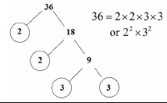

Topic/Skill | Definition/Tips | Example  Topic: Accuracy
1. Place Value | The value of where a digit is within a number. | In 726, the value of the 2 is 20, as it is in the ‘tens’ column.
2. Place Value Columns | The names of the columns that determine the value of each digit.  The ‘ones’ column is also known as the ‘units’ column. | 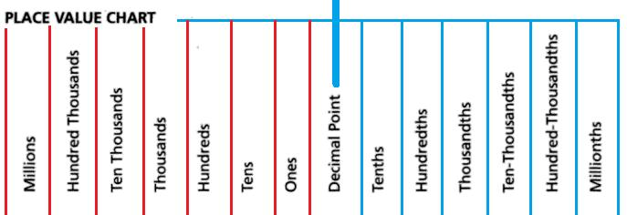
3. Rounding | To make a number simpler but keep its value close to what it was.  If the digit to the right of the rounding digit is less than 5, round down.  If the digit to the right of the rounding digit is 5 or more, round up. | 74 rounded to the nearest ten is 70, because 74 is closer to 70 than 80.  152,879 rounded to the nearest thousand is 153,000.
4. Decimal Place | The position of a digit to the right of a decimal point. | In the number 0.372, the 7 is in the second decimal place.  0.372 rounded to two decimal places is 0.37, because the 2 tells us to round down.  Careful with money - don’t write £27.4, instead write £27.40
5. Significant Figure | The significant figures of a number are the digits which carry meaning (ie. are significant) to the size of the number.  The first significant figure of a number cannot be zero.  In a number with a decimal, trailing zeros are not significant. | In the number 0.00821, the first significant figure is the 8.  In the number 2.740, the 0 is not a significant figure.  0.00821 rounded to 2 significant figures is 0.0082.  19357 rounded to 3 significant figures is 19400. We need to include the two zeros at the end to keep the digits in the same place value columns.
6. Truncation | A method of approximating a decimal number by dropping all decimal places past a certain point without rounding. | 3.14159265… can be truncated to 3.1415 (note that if it had been rounded, it would become 3.1416)
7. Error Interval | A range of values that a number could have taken before being rounded or truncated.  An error interval is written using inequalities, with a lower bound and an upper bound.  Note that the lower bound inequality can be ‘equal to’, but the upper bound cannot be ‘equal to’. | 0.6 has been rounded to 1 decimal place.  The error interval is:  $$0.55≤x<0.65$$  The lower bound is 0.55  The upper bound is 0.65
8. Estimate | To find something close to the correct answer. | An estimate for the height of a man is 1.8 metres.
9. Approximation | When using approximations to estimate the solution to a calculation, round each number in the calculation to 1 significant figure.  $≈$means ‘approximately equal to’ | $$\frac{348+692}{0.526}≈\frac{300+700}{0.5}=2000$$  ‘Note that dividing by 0.5 is the same as multiplying by 2’

Knowledge Organiser

