Topic/Skill | Definition/Tips  Topic: Graphs and Graph Transformations | Example
1. Coordinates | Written in pairs. The first term is the x-coordinate (movement across). The second term is the y-coordinate (movement up or down) | 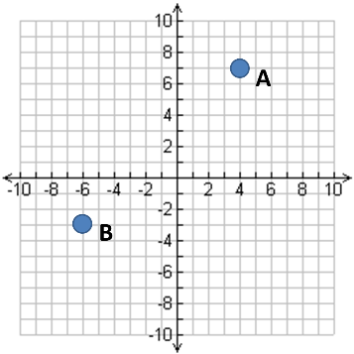  A: (4,7)  B: (-6,-3)
2. Linear Graph | Straight line graph.  The equation of a linear graph can contain an x-term, a y-term and a number. | Example:  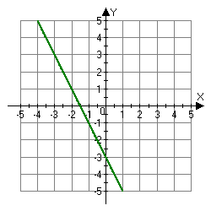  Other examples:  $x=y$  $y=4$  $x=-2$  $y=2x-7$  $y+x=10$  $2y-4x=12$
3. Quadratic Graph | A ‘U-shaped’ curve called a parabola.  The equation is of the form  $y=ax^{2}+bx+c$, where $a$, $b$ and $c$ are numbers, $a≠0$.  If $a<0$, the parabola is upside down. | 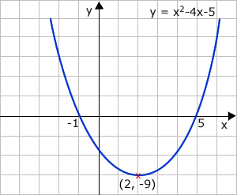
4. Cubic Graph | The equation is of the form $y={ax}^{3}+k$, where $k$ is an number.  If $a>0$, the curve is increasing.  If $a<0$, the curve is decreasing.
5. Reciprocal Graph | The equation is of the form $y=\frac{A}{x}$, where $A$ is a number and $x≠0$.  The graph has asymptotes on the x-axis and y-axis. | 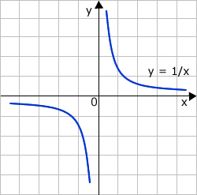
6. Asymptote | A straight line that a graph approaches but never touches.  Subject: Maths | 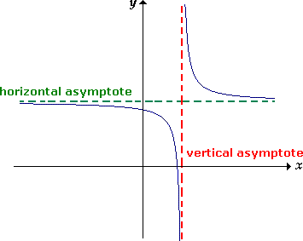
7. Exponential Graph | The equation is of the form $y=a^{x}$, where $a$is a number called the base.  If $a>1$ the graph increases.  If $0<a<1$, the graph decreases.  The graph has an asymptote which is the x-axis.
8. $y=\sin{x}$ | Key Coordinates:  $$\left(0,0\right), \left(90,1\right), \left(180,0\right), \left(270,-1\right), (360,0)$$  $y$ is never more than 1 or less than -1.  Pattern repeats every 360°. | 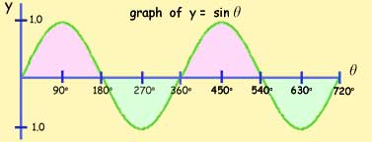
9. $y=\cos{x}$ | Key Coordinates:  $$\left(0,1\right), \left(90,0\right), \left(180,-1\right), \left(270,0\right), (360,1)$$  $y$ is never more than 1 or less than -1.  Pattern repeats every 360°. | 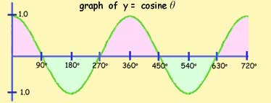
10. $y=\tan{x}$ | Key Coordinates:  $$\left(0,0\right), \left(45,1\right), \left(135,-1\right), \left(180,0\right),$$  $$\left(225,1\right), \left(315,-1\right), (360,0)$$  Asymptotes at $x=90$ and $x=270$  Pattern repeats every 360°. | 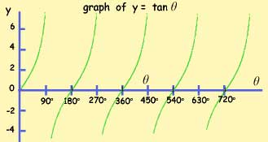
11. $f\left(x\right)+a$ | Vertical translation up a units. $\left(\begin{matrix}0 \\ a\end{matrix}\right)$ | 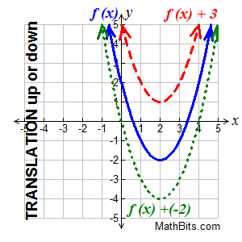
12. $f(x+a)$ | Horizontal translation left a units. $\left(\begin{matrix}-a \\ 0\end{matrix}\right)$ | 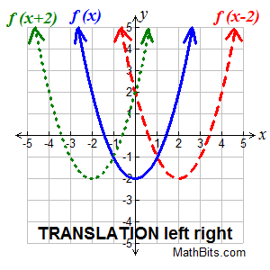
13. $-f(x)$ | Reflection over the x-axis. | 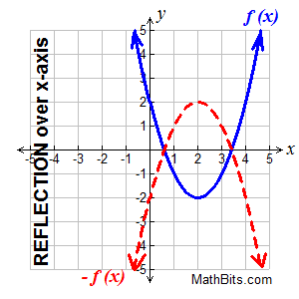
14. $f(-x)$ | Reflection over the y-axis. | 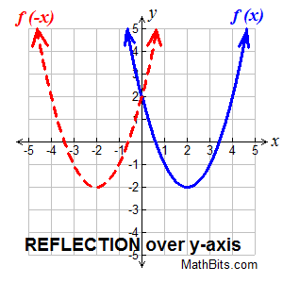
Topic/Skill | Definition/Tips | Example  Topic: Proportion
1. Direct Proportion | If two quantities are in direct proportion, as one increases, the other increases by the same percentage.  If $y$ is directly proportional to $x$, this can be written as $y ∝ x$  An equation of the form $y=kx$represents direct proportion, where $k$ is the constant of proportionality. | 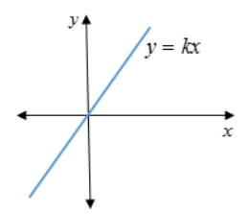
2. Inverse Proportion | If two quantities are inversely proportional, as one increases, the other decreases by the same percentage.  If $y$ is inversely proportional to $x$, this can be written as $y ∝\frac{1}{x}$  An equation of the form $y=\frac{k}{x}$ represents inverse proportion. | 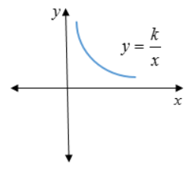
3. Using proportionality formulae | Direct: y = kx or y$∝$x  Inverse: y = $\frac{k}{x}$ or y $∝$ $\frac{1}{x}$  1. Solve to find k using the pair of values in the question.  2. Rewrite the equation using the k you have just found.  3. Substitute the other given value from the question in to the equation to find the missing value. | p is directly proportional to q.  When p = 12, q = 4.  Find p when q = 20.  1. p = kq  12 = k x 4  so k = 3  2. p = 3q  3. p = 3 x 20 = 60, so p = 60
4. Direct Proportion with powers | Graphs showing direct proportion can be written in the form $y=kx^{n}$  Direct proportion graphs will always start at the origin. | 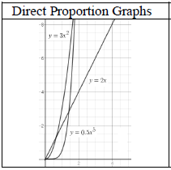
5. Inverse Proportion with powers | Graphs showing inverse proportion can be written in the form $y=\frac{k}{x^{n}}$  Inverse proportion graphs will never start at the origin. | 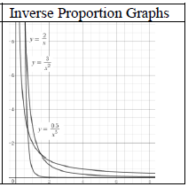
Topic/Skill | Definition/Tips | Example  Topic: Area Under Graph and Gradient of Curve
1. Area Under a Curve | To find the area under a curve, split it up into simpler shapes – such as rectangles, triangles and trapeziums – that approximate the area. | 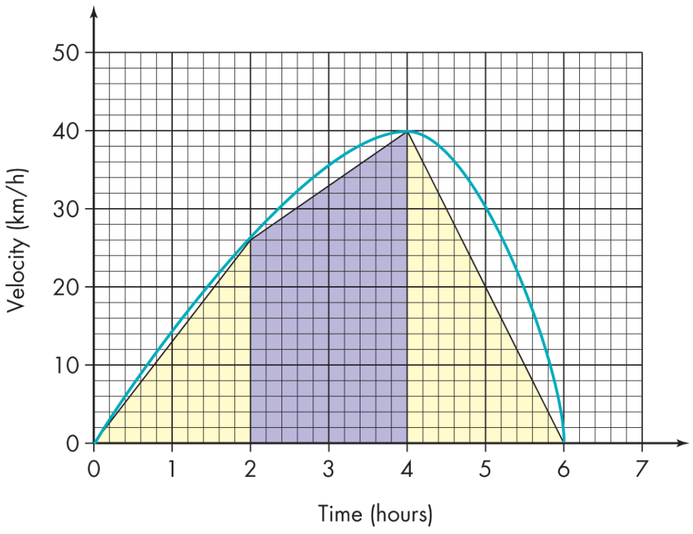
2. Tangent to a Curve | A straight line that touches a curve at exactly one point. | 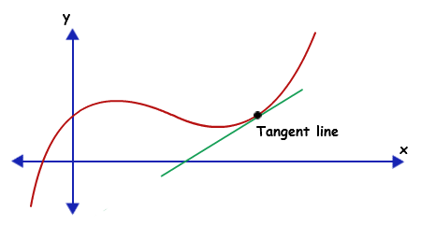
3. Gradient of a Curve | The gradient of a curve at a point is the same as the gradient of the tangent at that point.  1. Draw a tangent carefully at the point.  2. Make a right-angled triangle.  3. Use the measurements on the axes to calculate the rise and run (change in y and change in x)  4. Calculate the gradient. | 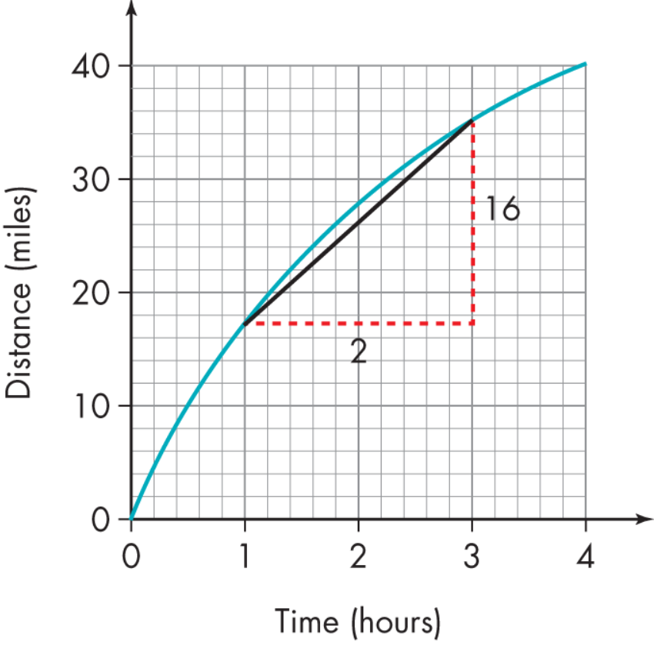  $$Gradient=\frac{Change in y}{Change in x}$$  $$=\frac{16}{2}=8$$
4. Rate of Change | The rate of change at a particular instant in time is represented by the gradient of the tangent to the curve at that point. | 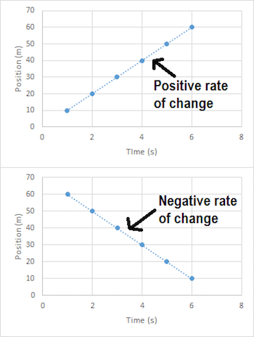
5. Distance-Time Graphs | You can find the speed from the gradient of the line (Distance ÷ Time)  The steeper the line, the quicker the speed.  A horizontal line means the object is not moving (stationary). | 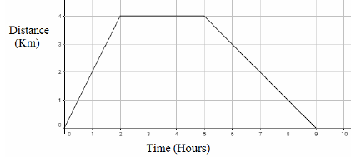
6. Velocity-Time Graphs | You can find the acceleration from the gradient of the line (Change in Velocity ÷ Time)  The steeper the line, the quicker the acceleration.  A horizontal line represents no acceleration, meaning a constant velocity.  The area under the graph is the distance. | 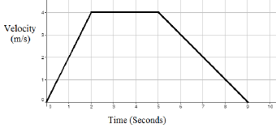

Knowledge Organiser

