Topic/Skill | Definition/Tips | Example  Topic: Congruence and Similarity
1. Congruent Shapes | Shapes are congruent if they are identical - same shape and same size.  Shapes can be rotated or reflected but still be congruent. | 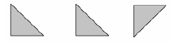
2. Congruent Triangles | 4 ways of proving that two triangles are congruent:  1. SSS (Side, Side, Side)  2. RHS (Right angle, Hypotenuse, Side)  3. SAS (Side, Angle, Side)  4. ASA (Angle, Side, Angle) or AAS  ASS does not prove congruency. | 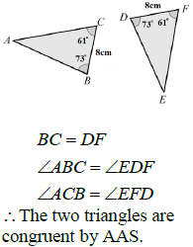
3. Similar Shapes | Shapes are similar if they are the same shape but different sizes.  The proportion of the matching sides must be the same, meaning the ratios of corresponding sides are all equal. | 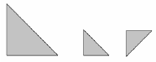
4. Scale Factor | The ratio of corresponding sides of two similar shapes.  To find a scale factor, divide a length on one shape by the corresponding length on a similar shape. | 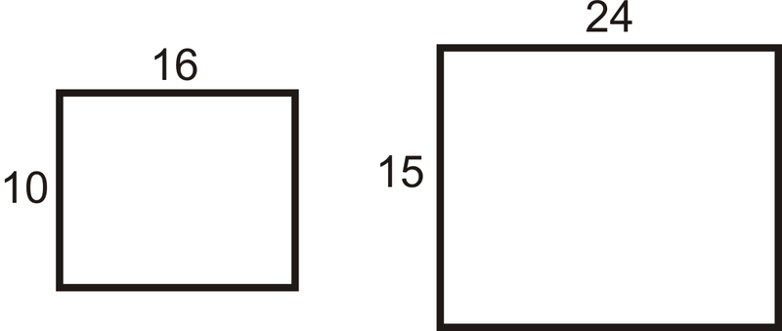  Scale Factor = $15÷10=1.5$
5. Finding missing lengths in similar shapes | 1. Find the scale factor.  2. Multiply or divide the corresponding side to find a missing length.  If you are finding a missing length on the larger shape you will need to multiply by the scale factor.  If you are finding a missing length on the smaller shape you will need to divide by the scale factor. | 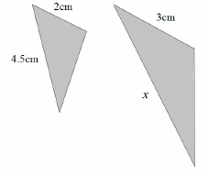  Scale Factor = $3÷2=1.5$  $x=4.5×1.5=6.75cm$
6. Similar Triangles | To show that two triangles are similar, show that:  1. The three sides are in the same proportion  2. Two sides are in the same proportion, and their included angle is the same  3. The three angles are equal
Topic/Skill | Definition/Tips  Topic: Vectors | Example
1. Translation | Translate means to move a shape.  The shape does not change size or orientation. | 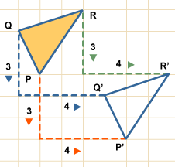
2. Vector Notation | A vector can be written in 3 ways:  a or $\vec{AB}$ or $\left(\begin{matrix}1 \\ 3\end{matrix}\right)$
3. Column Vector | In a column vector, the top number moves left (-) or right (+) and the bottom number moves up (+) or down (-) | $\left(\begin{matrix}2 \\ 3\end{matrix}\right)$ means ‘2 right, 3 up’  $\left(\begin{matrix}-1 \\ -5\end{matrix}\right)$ means ‘1 left, 5 down’
4. Vector | A vector is a quantity represented by an arrow with both direction and magnitude.  $$\vec{AB}=-\vec{BA}$$
5. Magnitude | Magnitude is defined as the length of a vector. | 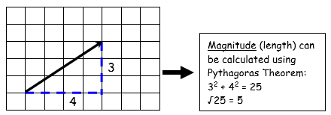
6. Equal Vectors | If two vectors have the same magnitude and direction, they are equal. | 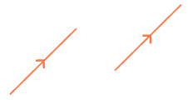
7. Parallel Vectors | Parallel vectors are multiples of each other. | 2a+b and 4a+2b are parallel as they are multiple of each other.  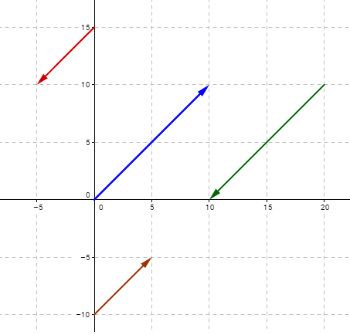
8. Resultant Vector | The resultant vector is the vector that results from adding two or more vectors together.  The resultant can also be shown by lining up the head of one vector with the tail of the other. | if a = $\left({4 \atop 4}\right)$ and b = $\left({2 \atop -2}\right)$  then a + b = $\left({4 \atop 4}\right)$ + $\left({2 \atop -2}\right)$ = $\left({6 \atop 2}\right)$  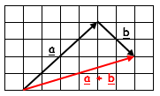
9. Scalar of a Vector | A scalar is the number we multiply a vector by. | 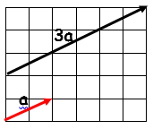  Example:  3a + 2b =  = 3$\left({2 \atop 1}\right)$ + 2$\left({4 \atop -1}\right)$  = $\left({6 \atop 3}\right)$ + $\left({8 \atop -2}\right)$  = $\left({14 \atop 1}\right)$

Knowledge Organiser

