Topic/Skill | Definition/Tips | Example  Topic: Perimeter and Area
1. Perimeter | The total distance around the outside of a shape.  Units include: $mm, cm, m$etc. | 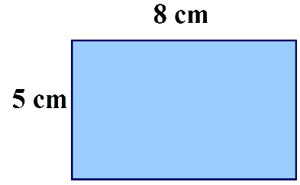  $P=8+5+8+5=26cm$
2. Area | The amount of space inside a shape.  Units include: $mm^{2}, cm^{2}, m^{2}$ | 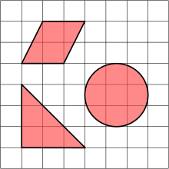
3. Area of a Rectangle | Length x Width | $A=36cm^{2}$
4. Area of a Parallelogram | Base x Perpendicular Height  Not the slant height. | $A=21cm^{2}$
5. Area of a Triangle | Base x Height ÷ 2 | 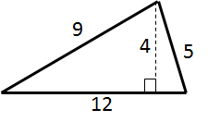$A=24cm^{2}$
6. Area of a Kite | Split in to two triangles and use the method above. | 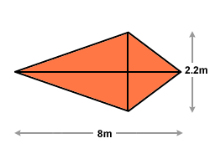 $A=8.8m^{2}$
7. Area of a Trapezium | $$\frac{(a+b)}{2}×h$$  “Half the sum of the parallel side, times the height between them. That is how you calculate the area of a trapezium” | 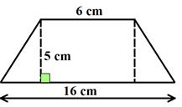 $A=55cm^{2}$
8. Compound Shape | A shape made up of a combination of other known shapes put together. | 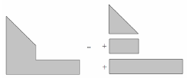

Topic/Skill | Definition/Tips | Example  Topic: Volume
1. Volume | Volume is a measure of the amount of space inside a solid shape.  Units: $mm^{3}, cm^{3},m^{3}$ etc.
2. Volume of a Cube/Cuboid | $$V=Length×Width×Height$$  $$V=L×W×H$$  You can also use the Volume of a Prism formula for a cube/cuboid.
3. Prism | A prism is a 3D shape whose cross section is the same throughout. | 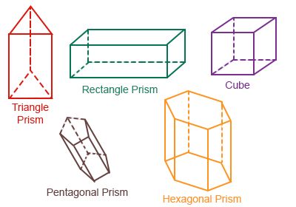
4. Cross Section | The cross section is the shape that continues all the way through the prism. | 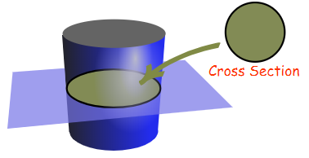
5. Volume of a Prism | $$V= Area of Cross Section×Length$$  $$V=A×L$$ | 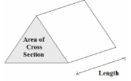
6. Volume of a Cylinder | $$V=πr^{2}h$$ | 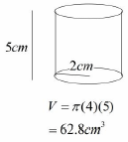
7. Volume of a Cone | $$V=\frac{1}{3}πr^{2}h$$ | 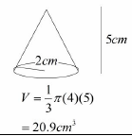
8. Volume of a Pyramid | $$Volume= \frac{1}{3}Bh$$  where B = area of the base | 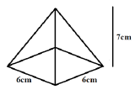  $$V=\frac{1}{3}×6×6×7=84{cm}^{3}$$
9. Volume of a Sphere | $$V=\frac{4}{3}πr^{3}$$  Look out for hemispheres – just halve the volume of a sphere. | Find the volume of a sphere with diameter 10cm.  $$V=\frac{4}{3}π{(5)}^{3}=\frac{500π}{3}{cm}^{3}$$
10. Frustums | A frustum is a solid (usually a cone or pyramid) with the top removed.  Find the volume of the whole shape, then take away the volume of the small cone/pyramid removed at the top. | 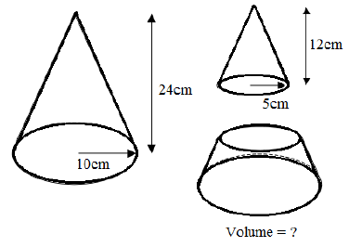  Topic: Geometry and Measures (H)  $$V=\frac{1}{3}π{\left(10\right)}^{2}\left(24\right)-\frac{1}{3}π{\left(5\right)}^{2}\left(12\right)=700π{cm}^{3}$$

Topic/Skill | Definition/Tips | Example  Topic: Circumference and Area
1. Circle | A circle is the locus of all points equidistant from a central point.
2. Parts of a Circle | Radius – the distance from the centre of a circle to the edge  Diameter – the total distance across the width of a circle through the centre.  Circumference – the total distance around the outside of a circle  Chord – a straight line whose end points lie on a circle  Tangent – a straight line which touches a circle at exactly one point  Arc – a part of the circumference of a circle  Sector – the region of a circle enclosed by two radii and their intercepted arc  Segment – the region bounded by a chord and the arc created by the chord | 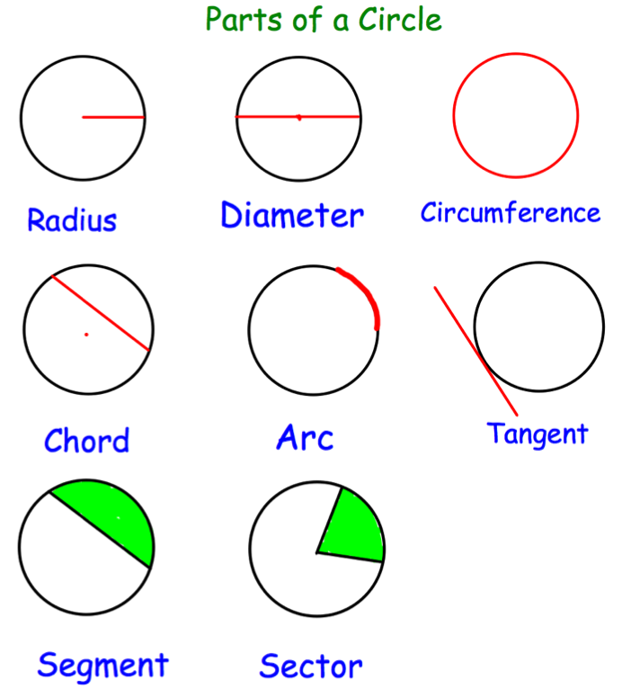
3. Area of a Circle | $A=πr^{2}$ which means ‘pi x radius squared’. | If the radius was 5cm, then:  $$A=π×5^{2}=78.5{cm}^{2}$$
4. Circumference of a Circle | $C=πd$ which means ‘pi x diameter’ | If the radius was 5cm, then:  $$C=π×10=31.4cm$$
5. $π$ (‘pi’) | Pi is the circumference of a circle divided by the diameter.  $$π≈3.14$$ | 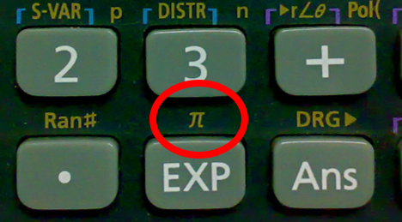
6. Arc Length of a Sector | The arc length is part of the circumference.  Take the angle given as a fraction over 360° and multiply by the circumference. | Arc Length = $\frac{115}{360}×π×8=8.03cm$  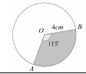
7. Area of a Sector | The area of a sector is part of the total area.  Take the angle given as a fraction over 360° and multiply by the area. | Area = $\frac{115}{360}×π×4^{2}=16.1{cm}^{2}$
8. Surface Area of a Cylinder | Curved Surface Area = $πdh$ or $2πrh$  Total SA = $2πr^{2}+πdh$ or $2πr^{2}+2πrh$ | 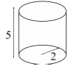  $$Total SA=2π{(2)}^{2}+π\left(4\right)\left(5\right)=28π$$
9. Surface Area of a Cone | Curved Surface Area = $πrl$  where $l=slant height$  Total SA = $πrl+ πr^{2}$  You may need to use Pythagoras’ Theorem to find the slant height | 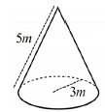  $$Total SA= π\left(3\right)\left(5\right)+π{(3)}^{2}=24π$$
10. Surface Area of a Sphere | $$SA=4πr^{2}$$  Look out for hemispheres – halve the SA of a sphere and add on a circle $(πr^{2})$ | Find the surface area of a sphere with radius 3cm.  $$SA=4π{(3)}^{2}=36π{cm}^{2}$$

Knowledge Organiser

