Topic/Skill | Definition/Tips | Example  Topic: Solving Quadratics by Factorising
1. Quadratic | A quadratic expression is of the form  $$ax^{2}+bx+c$$  where $a, b$ and $c$ are numbers, $a≠0$ | Examples of quadratic expressions:  $$x^{2}$$  $$8x^{2}-3x+7$$  Examples of non-quadratic expressions:  $$2x^{3}-5x^{2}$$  $$9x-1$$
2. Factorising Quadratics | When a quadratic expression is in the form $x^{2}+bx+c$ find the two numbers that add to give b and multiply to give c. | $$x^{2}+7x+10=(x+5)(x+2)$$  (because 5 and 2 add to give 7 and multiply to give 10)  $$x^{2}+2x-8=(x+4)(x-2)$$  (because +4 and -2 add to give +2 and multiply to give -8)
3. Difference of Two Squares | An expression of the form $a^{2}-b^{2}$ can be factorised to give $(a+b)(a-b)$ | $$x^{2}-25=(x+5)(x-5)$$  $$16x^{2}-81=(4x+9)(4x-9)$$
4. Solving Quadratics $(ax^{2}=b)$ | Isolate the $x^{2}$ term and square root both sides.  Remember there will be a positive and a negative solution. | $$2x^{2}=98$$  $$x^{2}=49$$  $$x=±7$$
5. Solving Quadratics $(ax^{2}+bx=0)$ | Factorise and then solve = 0. | $$x^{2}-3x=0$$  $$x\left(x-3\right)=0$$  $$x=0 or x=3$$
6. Solving Quadratics by Factorising  $\left(a=1\right)$ | Factorise the quadratic in the usual way.  Solve = 0  Make sure the equation = 0 before factorising. | Solve $x^{2}+3x-10=0$  Factorise: $\left(x+5\right)\left(x-2\right)=0$  $$x=-5 or x=2$$
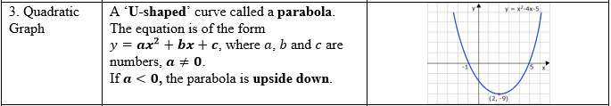
3. Quadratic Graph | A ‘U-shaped’ curve called a parabola.  The equation is of the form  $y=ax^{2}+bx+c$, where $a$, $b$ and $c$ are numbers, $a≠0$.  If $a<0$, the parabola is upside down. | 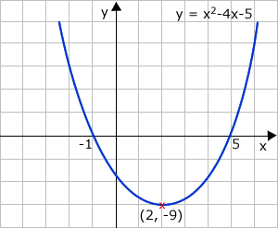
3. Quadratic Graph | A ‘U-shaped’ curve called a parabola.  The equation is of the form  $y=ax^{2}+bx+c$, where $a$, $b$ and $c$ are numbers, $a≠0$.  If $a<0$, the parabola is upside down.

3. Quadratic Graph | A ‘U-shaped’ curve called a parabola.  The equation is of the form  $y=ax^{2}+bx+c$, where $a$, $b$ and $c$ are numbers, $a≠0$.  If $a<0$, the parabola is upside down.

Knowledge Organiser

