Topic/Skill | Definition/Tips | Example  Topic: Circle Theorems
Circle Theorem 1 | Angles in a semi-circle have a right angle at the circumference.  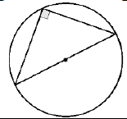 | 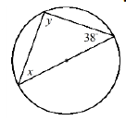  $$y=90°$$  $$x=180-90-38=52°$$
Circle Theorem 2 | Opposite angles in a cyclic quadrilateral add up to 180°.  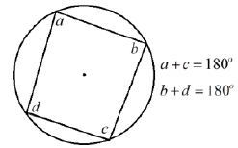 | 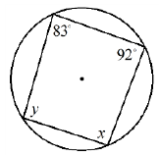  $$x=180-83=97°$$  $$y=180-92=88°$$
Circle Theorem 3 | The angle at the centre is twice the angle at the circumference.  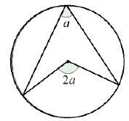 | 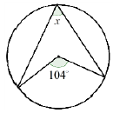  $$x=104÷2=52°$$
Circle Theorem 4 | Angles in the same segment are equal.  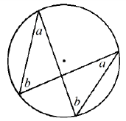 | 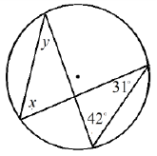  $$x=42°$$  $$y=31°$$
Circle Theorem 5 | A tangent is perpendicular to the radius at the point of contact.  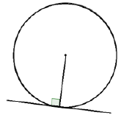 | 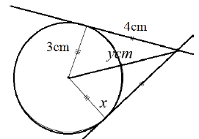  $y=5cm$(Pythagoras’ Theorem)
Circle Theorem 6 | Tangents from an external point at equal in length.  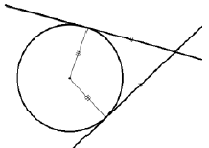 | $$x=90°$$
Circle Theorem 7 | Alternate Segment Theorem  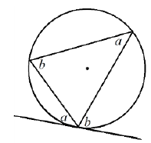 | 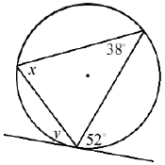  $$x=52°$$  $$y=38°$$

Topic/Skill | Definition/Tips  Topic: Equation of a Circle and Tangent | Example
1. Equation of a Circle | The equation of a circle, centre (0,0), radius r, is:  $$x^{2}+y^{2}=r^{2}$$ | 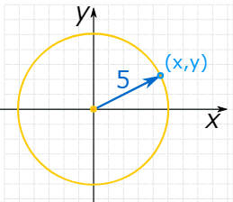  $$x^{2}+y^{2}=25$$
2. Tangent | A straight line that touches a circle at exactly one point, never entering the circle’s interior.  A radius is perpendicular to a tangent at the point of contact. | 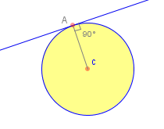
3. Gradient | Gradient is another word for slope.  $$G= \frac{Rise}{Run}= \frac{Change in y}{Change in x}= \frac{y_{2}-y_{1}}{x_{2}-x_{1}}$$ | 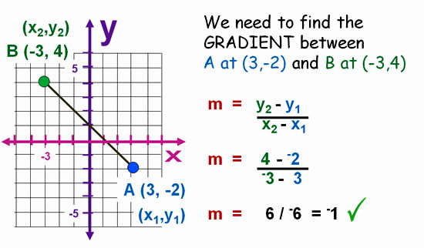
4. Circle Theorem 5 | A tangent is perpendicular to the radius at the point of contact. | $y=5cm$(Pythagoras’ Theorem)

Knowledge Organiser

