Topic/Skill | Definition/Tips  Topic: Iteration | Example
1. Iteration | The act of repeating a process over and over again, often with the aim of approximating a desired result more closely.  Recursive Notation: $x_{n+1}=\sqrt{3x_{n}+6}$ | $$x_{1}=4$$  $$x_{2}=\sqrt{3×4+6}=4.242640…$$  $$x_{3}=\sqrt{3×4.242640…+6}=4.357576…$$
2. Iterative Method | To create an iterative formula, rearrange an equation with more than one x term to make one of the x terms the subject.  You will be given the first value to substitute in, often called $x_{1}$.  Keep substituting in your previous answer until your answers are the same to a certain degree of accuracy. This is called converging to a limit.  Use the ‘ANS’ button on your calculator to keep substituting in the previous answer. | Use an iterative formula to find the positive root of $x^{2}-3x-6=0$ to 3 decimal places.  $x_{1}=4$  Answer:  $$x^{2}=3x+6$$  $$x=\sqrt{3x+6}$$  So $x_{n+1}=\sqrt{3x_{n}+6}$  $$x_{1}=4$$  $$x_{2}=\sqrt{3×4+6}=4.242640…$$  $$x_{3}=\sqrt{3×4.242640…+6}=4.357576…$$  Keep repeating…  $$x_{7}=4.372068..=4.372 \left(3dp\right)$$  $$x_{8}=4.372208…=4.372 (3dp)$$  So answer is $x=4.372 (3dp)$
3. Solving Simultaneous Equations  (Graphically) | Draw the graphs of the two equations.  The solutions will be where the lines meet.  The solution can be written as a coordinate. | 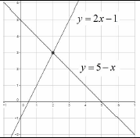  $y=5-x$ and $y=2x-1.$  They meet at the point with coordinates (2,3) so the answer is $x=2$ and $y=3$
4. Solving Linear and Quadratic Simultaneous Equations | Method 1: If both equations are in the same form (eg. Both $y=$…):  1. Set the equations equal to each other.  2. Rearrange to make the equation equal to zero.  3. Solve the quadratic equation.  4. Substitute the values back in to one of the equations.  Method 2: If the equations are not in the same form:  1. Rearrange the linear equation into the form $y=...$ or $x=...$  2. Substitute in to the quadratic equation.  3. Rearrange to make the equation equal to zero.  4. Solve the quadratic equation.  5. Substitute the values back in to one of the equations.  You should get two pairs of solutions (two values for $x$, two values for $y$.)  Graphically, you should have two points of intersection. | Example 1  Solve  $y=x^{2}-2x-5$ and $y=x-1$  $$x^{2}-2x-5=x-1$$  $$x^{2}-3x-4=0$$  $$\left(x-4\right)\left(x+1\right)=0$$  $x=4$ and $x=-1$  $y=4-1=3$ and  $y=-1-1=-2$  Answers: (4,3) and (-1,-2)  Example 2  Solve $x^{2}+y^{2}=5$ and $x+y=3$  $$x=3-y$$  $${\left(3-y\right)}^{2}+y^{2}=5$$  $$9-6y+y^{2}+y^{2}=5$$  $$2y^{2}-6y+4=0$$  $$y^{2}-3y+2=0$$  $$\left(y-1\right)\left(y-2\right)=0$$  $y=1$ and $y=2$  $x=3-1=2$ and $x=3-2=1$  Answers: (2,1) and (1,2)
5. Quadratic Graph | A ‘U-shaped’ curve called a parabola.  The equation is of the form  $y=ax^{2}+bx+c$, where $a$, $b$ and $c$ are numbers, $a≠0$.  If $a<0$, the parabola is upside down. | 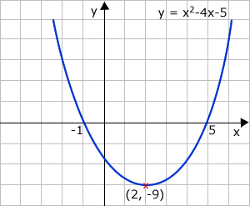
6. Roots of a Quadratic | A root is a solution.  The roots of a quadratic are the $x$-intercepts of the quadratic graph. | 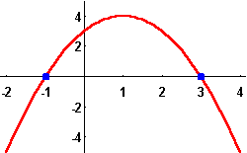
7. Turning Point of a Quadratic | A turning point is the point where a quadratic turns.  On a positive parabola, the turning point is called a minimum.  On a negative parabola, the turning point is called a maximum. | 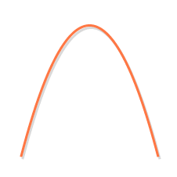
8. Cubic Graph | The equation is of the form $y={ax}^{3}+k$, where $k$ is an number.  If $a>0$, the curve is increasing.  If $a<0$, the curve is decreasing.
Subject: Maths

Knowledge Organiser

