Topic/Skill | Definition/Tips | Example  Topic: Compound Measures
1. Metric System | A system of measures based on:  - the metre for length  - the kilogram for mass  - the second for time  Length: mm, cm, m, km  Mass: mg, g, kg  Volume: ml, cl, l | $$1kilometres=1000 metres$$  $$1 metre=100 centimetres$$  $$1 centimetre=10 millimetres$$  $$1 kilogram=1000 grams$$
2. Imperial System | A system of weights and measures originally developed in England, usually based on human quantities  Length: inch, foot, yard, miles  Mass: lb, ounce, stone  Volume: pint, gallon | $$1lb=16 ounces$$  $$1 foot=12 inches$$  $$1 gallon=8 pints$$
3. Metric and Imperial Units | Use the unitary method to convert between metric and imperial units. | $$5 miles≈8 kilometres$$  $$1 gallon≈4.5 litres$$  $$2.2 pounds≈1 kilogram$$  $$1 inch=2.5 centimetres$$
4. Speed, Distance, Time | Speed = Distance ÷ Time  Distance = Speed x Time  Time = Distance ÷ Speed  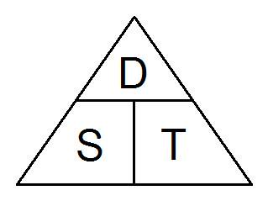  Remember the correct units. | Speed = 4mph  Time = 2 hours  Find the Distance.  $$D = S × T = 4 × 2 = 8 miles$$
5. Density, Mass, Volume | Density = Mass ÷ Volume  Mass = Density x Volume  Volume = Mass ÷ Density  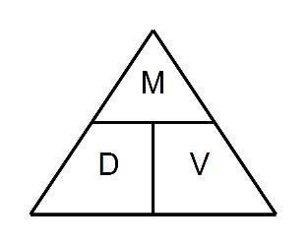  Remember the correct units. | Density = 8kg/m³  Mass = 2000g  Find the Volume.  $$V = M ÷ D = 2 ÷ 8 = 0.25m³$$
6. Pressure, Force, Area | Pressure = Force ÷ Area  Force = Pressure x Area  Area = Force ÷ Pressure  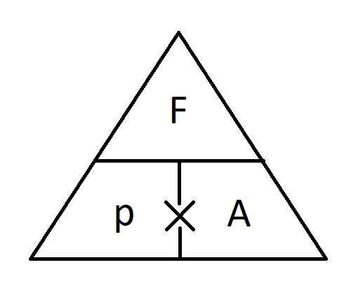  Remember the correct units. | Pressure = 10 Pascals  Area = 6cm²  Find the Force  $$F=P×A=10×6=60 N$$
7. Distance-Time Graphs | You can find the speed from the gradient of the line (Distance ÷ Time)  The steeper the line, the quicker the speed.  A horizontal line means the object is not moving (stationary). | 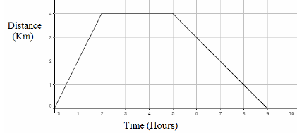

Topic/Skill | Definition/Tips | Example  Topic: Growth and Decay
1. Exponential Growth | When we multiply a number repeatedly by the same number ($≠1)$, resulting in the number increasing by the same proportion each time.  The original amount can grow very quickly in exponential growth. | $1, 2, 4, 8, 16, 32, 64, 128…$ is an example of exponential growth, because the numbers are being multiplied by 2 each time.
2. Exponential Decay | When we multiply a number repeatedly by the same number ($0<x<1)$, resulting in the number decreasing by the same proportion each time.  The original amount can decrease very quickly in exponential decay. | $1000, 200, 40, 8…$ is an example of exponential decay, because the numbers are being multiplied by $\frac{1}{5}$ each time.
3. Compound Interest | Interest paid on the original amount and the accumulated interest. | A bank pays 5% compound interest a year. Bob invests £3000. How much will he have after 7 years.  $$3000×{1.05}^{7}=£4221.30$$

Knowledge Organiser

