Topic/Skill | Definition/Tips | Example  Topic: Histograms and Cumulative Frequency
1. Histograms | A visual way to display frequency data using bars.  Bars can be unequal in width.  Histograms show frequency density on the y-axis, not frequency.  $$Frequency Density= \frac{Frequency}{Class Width}$$  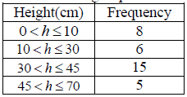 | 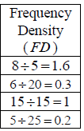  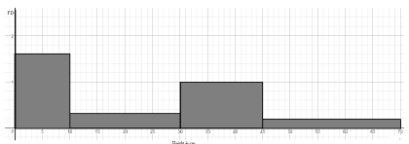
2. Interpreting Histograms | The area of the bar is proportional to the frequency of that class interval.  $$Frequency=Freq Density ×Class Width$$ | A histogram shows information about the heights of a number of plants. 4 plants were less than 5cm tall. Find the number of plants more than 5cm tall.  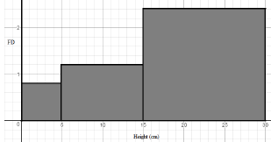  Above 5cm:  1.2 x 10 + 2.4 x 15 = 12 + 36 = 48
3. Cumulative Frequency | Cumulative Frequency is a running total.  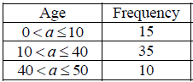 | 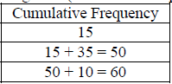
4. Cumulative Frequency Diagram | A cumulative frequency diagram is a curve that goes up. It looks a little like a stretched-out S shape.  Plot the cumulative frequencies at the end-point of each interval. | 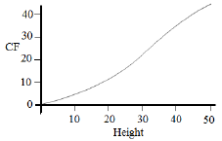
5. Quartiles from Cumulative Frequency Diagram | Lower Quartile (Q1): 25% of the data is less than the lower quartile.  Median (Q2): 50% of the data is less than the median.  Upper Quartile (Q3): 75% of the data is less than the upper quartile.  Interquartile Range (IQR): represents the middle 50% of the data. | 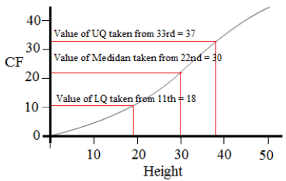  $$IQR=37-18=19$$
6. Hypothesis | A statement that might be true, which can be tested. | Hypothesis: ‘Large dogs are better at catching tennis balls than small dogs’.  We can test this hypothesis by having hundreds of different sized dogs try to catch tennis balls.

7. Box Plots | The minimum, lower quartile, median, upper quartile and maximum are shown on a box plot.  A box plot can be drawn independently or from a cumulative frequency diagram. | Students sit a maths test. The highest score is 19, the lowest score is 8, the median is 14, the lower quartile is 10 and the upper quartile is 17. Draw a box plot to represent this information.  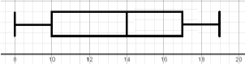
8. Comparing Box Plots | Write two sentences.  1. Compare the averages using the medians for two sets of data.  2. Compare the spread of the data using the range or IQR for two sets of data.  The smaller the range/IQR, the more consistent the data.  You must compare box plots in the context of the problem. | ‘On average, students in class A were more successful on the test than class B because their median score was higher.’  ‘Students in class B were more consistent than class A in their test scores as their IQR was smaller.’
9. Lower Quartile | Divides the bottom half of the data into two halves.  LQ = $Q_{1}=\frac{(n+1)}{4}th$value | Find the lower quartile of: 2, 3, 4, 5, 6, 6, 7  $Q_{1}=\frac{(7+1)}{4}=2nd$value 3
10. Lower Quartile | Divides the top half of the data into two halves.  UQ = $Q_{3}=\frac{3(n+1)}{4}th$value | Find the upper quartile of: 2, 3, 4, 5, 6, 6, 7  $Q_{3}=\frac{3(7+1)}{4}=6th$value 6
11. Interquartile Range | The difference between the upper quartile and lower quartile.  $$IQR=Q_{3}-Q_{1}$$  The smaller the interquartile range, the more consistent the data. | Find the IQR of: 2, 3, 4, 5, 6, 6, 7  $$IQR=Q_{3}-Q_{1}=6-3=3$$

Knowledge Organiser

