Topic/Skill | Definition/Tips | Example  Topic: Congruence and Similarity
1. Congruent Shapes | Shapes are congruent if they are identical - same shape and same size.  Shapes can be rotated or reflected but still be congruent. | 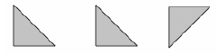
2. Congruent Triangles | 4 ways of proving that two triangles are congruent:  1. SSS (Side, Side, Side)  2. RHS (Right angle, Hypotenuse, Side)  3. SAS (Side, Angle, Side)  4. ASA (Angle, Side, Angle) or AAS  ASS does not prove congruency. | 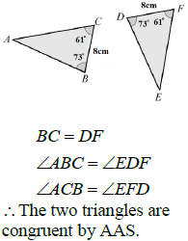
3. Similar Shapes | Shapes are similar if they are the same shape but different sizes.  The proportion of the matching sides must be the same, meaning the ratios of corresponding sides are all equal. | 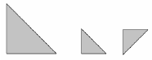
4. Scale Factor | The ratio of corresponding sides of two similar shapes.  To find a scale factor, divide a length on one shape by the corresponding length on a similar shape. | 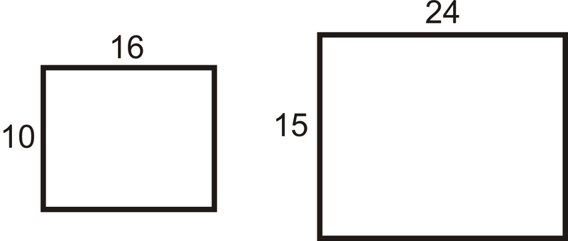  Scale Factor = $15÷10=1.5$
5. Finding missing lengths in similar shapes | 1. Find the scale factor.  2. Multiply or divide the corresponding side to find a missing length.  If you are finding a missing length on the larger shape you will need to multiply by the scale factor.  If you are finding a missing length on the smaller shape you will need to divide by the scale factor. | 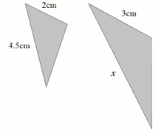  Scale Factor = $3÷2=1.5$  $x=4.5×1.5=6.75cm$
6. Similar Triangles | To show that two triangles are similar, show that:  1. The three sides are in the same proportion  2. Two sides are in the same proportion, and their included angle is the same  3. The three angles are equal
Topic/Skill | Definition/Tips  Topic: Proofs | Example
1. Expression | A mathematical statement written using symbols, numbers or letters, | 3x + 2 or 5y²
2. Equation | A statement showing that two expressions are equal | 2y – 17 = 15
3. Identity | An equation that is true for all values of the variables  An identity uses the symbol: $≡$ | 2x ≡ x+x
4. Formula | Shows the relationship between two or more variables | Area of a rectangle = length x width or A= LxW
5. Coefficient | A number used to multiply a variable.  It is the number that comes before/in front of a letter. | 6z  6 is the coefficient  z is the variable
6. Odds and Evens | An even number is a multiple of 2  An odd number is an integer which is not a multiple of 2. | If n is an integer (whole number):  An even number can be represented by 2n or 2m etc.  An odd number can be represented by 2n-1 or 2n+1 or 2m+1 etc.
7. Consecutive Integers | Whole numbers that follow each other in order. | If n is an integer:  n, n+1, n+2 etc. are consecutive integers.
8. Square Terms | A term that is produced by multiply another term by itself. | If n is an integer:  $n^{2}$, $m^{2}$ etc. are square integers
9. Sum | The sum of two or more numbers is the value you get when you add them together. | The sum of 4 and 6 is 10
10. Product | The product of two or more numbers is the value you get when you multiply them together. | The product of 4 and 6 is 24
11. Multiple | To show that an expression is a multiple of a number, you need to show that you can factor out the number. | $4n^{2}+8n-12$ is a multiple of 4 because it can be written as:  $$4(n^{2}+2n-3)$$

Knowledge Organiser

