Topic/Skill | Definition/Tips | Example  Topic: Shape Transformations
1. Translation | Translate means to move a shape.  The shape does not change size or orientation. | 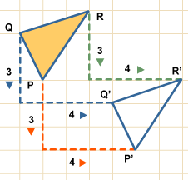
2. Column Vector | In a column vector, the top number moves left (-) or right (+) and the bottom number moves up (+) or down (-) | $\left(\begin{matrix}2 \\ 3\end{matrix}\right)$ means ‘2 right, 3 up’  $\left(\begin{matrix}-1 \\ -5\end{matrix}\right)$ means ‘1 left, 5 down’
3. Rotation | The size does not change, but the shape is turned around a point.  Use tracing paper. | Rotate Shape A 90° anti-clockwise about (0,1)  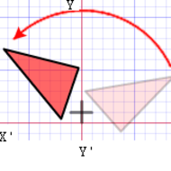
4. Reflection | The size does not change, but the shape is ‘flipped’ like in a mirror.  Line $x=?$ is a vertical line.  Line $y=?$ is a horizontal line.  Line $y=x$ is a diagonal line. | Reflect shape C in the line $y=x$  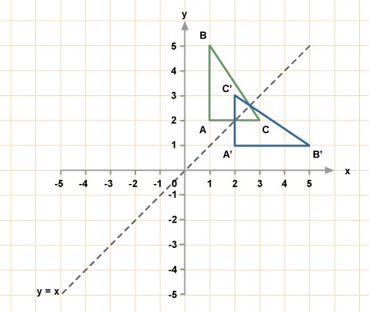
5. Enlargement | The shape will get bigger or smaller. Multiply each side by the scale factor. | Scale Factor = 3 means ‘3 times larger = multiply by 3’  Scale Factor = ½ means ‘half the size = divide by 2’
6. Finding the Centre of Enlargement | Draw straight lines through corresponding corners of the two shapes.  The centre of enlargement is the point where all the lines cross over.  Be careful with negative enlargements as the corresponding corners will be the other way around. | 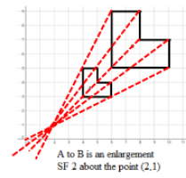
7. Describing Transformations | Give the following information when describing each transformation:  Look at the number of marks in the question for a hint of how many pieces of information are needed.  If you are asked to describe a ‘transformation’, you need to say the name of the type of transformation as well as the other details. | - Translation, Vector  - Rotation, Direction, Angle, Centre  - Reflection, Equation of mirror line  - Enlargement, Scale factor, Centre of enlargement
8. Negative Scale Factor Enlargements | Negative enlargements will look like they have been rotated.  $SF=-2$ will be rotated, and also twice as big. | Enlarge ABC by scale factor -2, centre (1,1)

Knowledge Organiser

