Topic/Skill | Definition/Tips | Example  Topic: Basic Probability
1. Probability | The likelihood/chance of something happening.  Is expressed as a number between 0 (impossible) and 1 (certain).  Can be expressed as a fraction, decimal, percentage or in words (likely, unlikely, even chance etc.) | 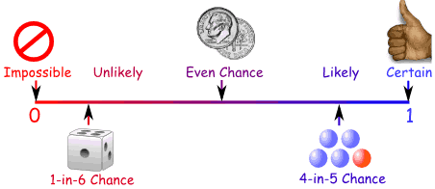
2. Probability Notation | P(A) refers to the probability that event A will occur. | P(Red Queen) refers to the probability of picking a Red Queen from a pack of cards.
3. Theoretical Probability | $$\frac{Number of Favourable Outcomes}{Total Number of Possible Outcomes}$$ | Probability of rolling a 4 on a fair 6-sided die = $\frac{1}{6}$.
4. Relative Frequency | $$\frac{Number of Successful Trials}{Total Number of Trials}$$ | A coin is flipped 50 times and lands on Tails 29 times.  The relative frequency of getting Tails = $\frac{29}{50}$.
5. Expected Outcomes | To find the number of expected outcomes, multiply the probability by the number of trials. | The probability that a football team wins is 0.2 How many games would you expect them to win out of 40?  $$0.2 × 40 = 8 games$$
6. Exhaustive | Outcomes are exhaustive if they cover the entire range of possible outcomes.  The probabilities of an exhaustive set of outcomes adds up to 1. | When rolling a six-sided die, the outcomes 1, 2, 3, 4, 5 and 6 are exhaustive, because they cover all the possible outcomes.
7. Mutually Exclusive | Events are mutually exclusive if they cannot happen at the same time.  The probabilities of an exhaustive set of mutually exclusive events adds up to 1. | Examples of mutually exclusive events:  - Turning left and right  - Heads and Tails on a coin  Examples of non mutually exclusive events:  - King and Hearts from a deck of cards, because you can pick the King of Hearts
8. Frequency Tree | A diagram showing how information is categorised into various categories.  The numbers at the ends of branches tells us how often something happened (frequency).  The lines connected the numbers are called branches. | 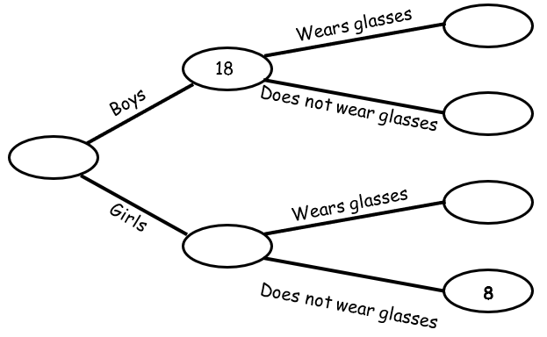
9. Sample Space | The set of all possible outcomes of an experiment.
10. Sample | A sample is a small selection of items from a population.  A sample is biased if individuals or groups from the population are not represented in the sample. | A sample could be selecting 10 students from a year group at school.
11. Sample Size | The larger a sample size, the closer those probabilities will be to the true probability. | A sample size of 100 gives a more reliable result than a sample size of 10.

Topic/Skill | Definition/Tips | Example  Topic: Probability (Trees and Venns)
1. Tree Diagrams | Tree diagrams show all the possible outcomes of an event and calculate their probabilities.  All branches must add up to 1 when adding downwards.  This is because the probability of something not happening is 1 minus the probability that it does happen.  Multiply going across a tree diagram.  Add going down a tree diagram. | 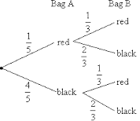
2. Independent Events | The outcome of a previous event does not influence/affect the outcome of a second event. | An example of independent events could be replacing a counter in a bag after picking it.
3. Dependent Events | The outcome of a previous event does influence/affect the outcome of a second event. | An example of dependent events could be not replacing a counter in a bag after picking it.  ‘Without replacement’
4. Probability Notation | P(A) refers to the probability that event A will occur.  P(A’) refers to the probability that event A will not occur.  P(A $∪$B) refers to the probability that event A or B or both will occur.  P(A $∩$B) refers to the probability that both events A and B will occur. | P(Red Queen) refers to the probability of picking a Red Queen from a pack of cards.  P(Blue’) refers to the probability that you do not pick Blue.  P(Blonde $∪$ Right Handed) refers to the probability that you pick someone who is Blonde or Right Handed or both.  P(Blonde $∩$ Right Handed) refers to the probability that you pick someone who is both Blonde and Right Handed.
5. Venn Diagrams | A Venn Diagram shows the relationship between a group of different things and how they overlap.  You may be asked to shade Venn Diagrams as shown below and to the right.  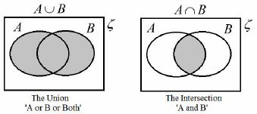 | 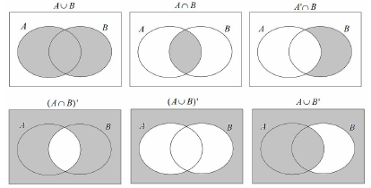
6. Venn Diagram Notation | $∈$ means ‘element of a set’ (a value in the set)  { } means the collection of values in the set.  $ξ$means the ‘universal set’ (all the values to consider in the question)  A’ means ‘not in set A’ (called complement)  A $∪$B means ‘A or B or both’ (called Union)  A $∩$B means ‘A and B (called Intersection) | Set A is the even numbers less than 10.  A = {2, 4, 6, 8}  Set B is the prime numbers less than 10.  B = {2, 3, 5, 7}  A $∪$B = {2, 3, 4, 5, 6, 7, 8}  A $∩$B = {2}
7. AND rule for Probability | When two events, A and B, are independent:  $$P\left(A and B\right)=P(A)×P(B)$$ | What is the probability of rolling a 4 and flipping a Tails?  $$P\left(4 and Tails\right)=P\left(4\right)×P\left(Tails\right)$$  $$=\frac{1}{6}×\frac{1}{2}=\frac{1}{12}$$
8. OR rule for Probability | When two events, A and B, are mutually exclusive:  $$P\left(A or B\right)=P\left(A\right)+P(B)$$ | What is the probability of rolling a 2 or rolling a 5?  $$P\left(2 or 5\right)=P\left(2\right)+P\left(5\right)$$  $$=\frac{1}{6}+\frac{1}{6}=\frac{2}{6}=\frac{1}{3}$$
9. Conditional Probability | The probability of an event A happening, given that event B has already happened.  With conditional probability, check if the numbers on the second branches of a tree diagram changes. For example, if you have 4 red beads in a bag of 9 beads and pick a red bead on the first pick, then there will be 3 red beads left out of 8 beads on the second pick. | 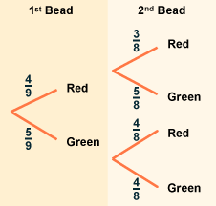

Knowledge Organiser

